Reactivation of Research Policies and Procedures for the Natural Sciences Building
post COVID-19 (Revision 6/12/2020)

Building Contacts:
For IBIO, Tom Getty (getty@msu.edu) or Katie Steinman (steinm50@msu.edu)
For EES, David Hyndman (hyndman@msu.edu) or Dallas Coryell (coryelld@msu.edu)
For ENT Bill Ravlin (ravlin@msu.edu) or Linda Gallagher (gallag14@msu.edu)

Preamble
This plan is being implemented to enable the reactivation of research in the Natural Sciences Building while there is still a risk of contracting the virus causing COVID-19 from co-workers. It is meant to comply with the guidelines provided by the Office of the Senior Vice President for Research and Innovation (OSVPRI), and all federal, state and county laws and guidelines.). These building-level policies and procedures been developed by the chairs of the three units with research labs in the Natural Science Building: Thomas Getty, Chair IBIO, David Hyndman, Chair of EES and Bill Ravlin, Chair of ENT. Two other units with offices in the building, MATRIX and the College of Natural Science were consulted and informed. This protocol might change or be rescinded, as changing conditions warrant or require. Activities in all laboratories of the building are limited to those that can only be done on campus—work that can be done from home should be done from home.

Nobody should be compelled to come to work as long as there is risk of contracting the virus causing COVID-19 from co-workers. MSU prohibits coercion of students and other vulnerable groups to report to campus to maintain their assistantship or postdoctoral research associate support. Undergraduate students should not be in the lab unless they are paid employees who are performing a critical function of the research. This document does not apply to research field sites on campus, at KBS or at remote locations. Separate guidelines and policies for field sites will need to be developed in coordination with the appropriate administrators of the facilities.

- The guiding principles of these Policies and Procedures include the following:
- The building has remained operational during the shutdown, equipment has been routinely monitored and repaired as needed by essential personnel, and in principle, the building is ready for resumption of work following inspections by IPF and EHS. It is understood that the bathrooms and common areas are cleaned daily by the janitorial staff in addition to measures described below upon return to work.
- At no time will research with active virus causing COVID-19 be conducted in the Natural Science Building.
- The risk of going back to work in the lab with other colleagues includes contracting the virus causing COVID-19 from another contagious person by aerosol or contaminated surfaces. Keep in mind, a contagious person may not have symptoms.
- Precautions need to be added on top of existing lab safety protocols and these new precautions do not obviate the need to maintain existing lab safety protocols.
- Three levels of training on new policies and procedures are required for all those returning to work in the NatSci Bldg.: (1) EHS online (bit.ly//EHS-4950-SCO), (2) this Building Plan, and (3) the Individual Lab Plan. Building access may not be granted until EHS training has been completed and documented. Everyone must acknowledge reading this document, before participating in a unit-level meeting where the Chair/Director will go over the rules and answer questions.
- This protocol will remain binding until the MSU Office of Regulatory Affairs (ORA) or the Office of the Senior Vice President for Research and Innovation (OSVPRI) allow for (or require) modifications. Changes to this protocol will be distributed to all building occupants and their supervisors by email, postings will be made at the entrances of the building, and on the EES, IBIO, and ENT department websites.

- Building preparation, Access, and Sanitation of Shared Rooms and Common Areas:
- Building Preparation: During the shutdown the building has been monitored regularly by essential workers and technicians, and issues have been resolved in collaboration with Infrastructure Planning and Facilities/Facilities Planning (IPF). As required, before research reactivation can begin, the building will be prepared by IPF and Space Management/ Environmental Health and Safety (EHS) to ensure it is clean and functioning appropriately. Water and HVAC systems and fume hoods have been checked. Biosafety cabinets and autoclaves will be checked by lab managers, as specified in individual laboratory reactivation forms, and will be recertified as needed. A spreadsheet will be created by the three building contacts listed at the top of this document to help prioritize the order in which labs reopen as well as a ramp down should this become necessary.
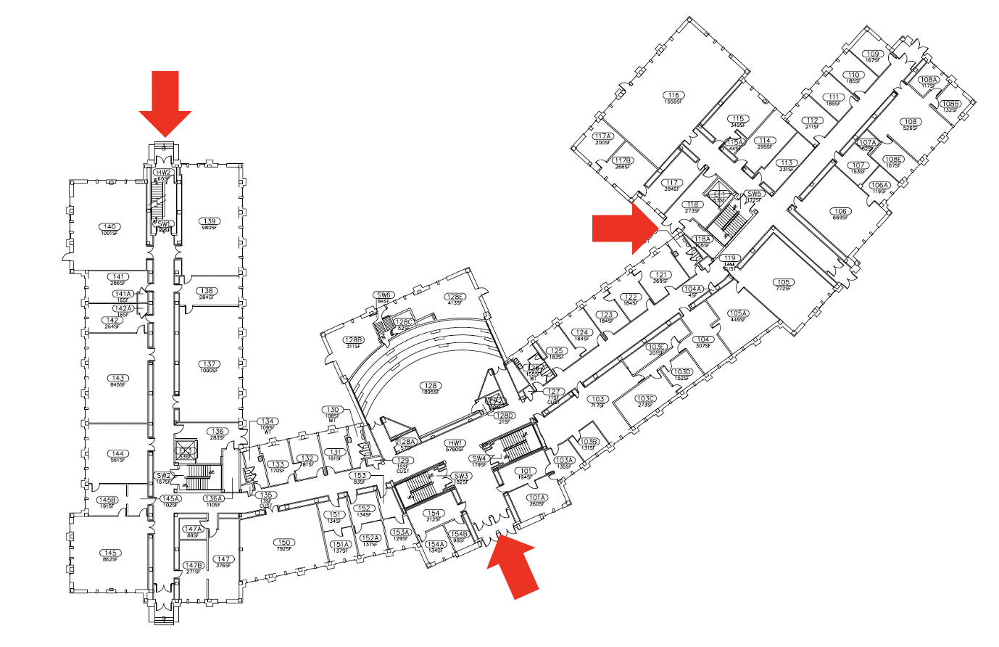
- Building Access: The building will remain locked and access controlled. Access will be limited to only those faculty, staff and students who have been trained in and acknowledge the policies and procedures in this document. With the exception of emergencies, like fire escape, building entry and exit points will be limited to the three doorways indicated on this first-floor plan: People must maintain a social distance >6’ at the doorways in all public, common-use areas. People exiting the building have priority at the doorways. People should wash or sanitize their hands upon entering or exiting the building. Hand sanitizer will be available at each of these approved entrances. If the sanitizer is not available, hands can be washed in the lab or bathroom. Access and presence in the building will be monitored using an online self-check-in/check-out webform established and maintained by the NatSci building contacts. Access may be revoked by unit Chairs or Directors for anyone found in violation of policies and procedures.
- Deliveries: Deliveries will be go directly to the CNS mail room (room 107); there are no room to room deliveries. Nat Sci staff will be responsible for checking the mail room for their shipments during the day (they can also track parcel whereabouts via the carrier’s website and Stores-Logistics website, see below). Upon receipt at central receiving, the parcel is processed and placed into the university tracking system, U-Track. U-Track is found on the stores home page, usd.msu.edu > Logistics > U-Track. Either the carrier’s tracking number or a reference number, i.e. PO, REQ is entered into the appropriate field for tracking purposes. When FedEx and UPS deliveries are ordered, the person(s) ordering items divert delivery to MSU central receiving at 166 Service Road (Airgas must continue to deliver direct to buildings as stores will not accept cylinder deliveries). The recipient name and building name should be part of the ship-to address as well as the PO reference number, i.e. Joan Smith, EES Department, Natural Science Building, 288 Farm Lane, East Lansing, MI 48824. Stores personnel completes the COVID19 Workplace Health form each morning upon arrival, and will wear face covering when in buildings. Signs will be posted at central receiving requiring all delivery drivers wear face coverings and our staff is charged with ensuring 3rd party persons face coverings are worn at all times within our building.
- External Contractors and Vendor Repair Personnel: External contractors and vendor repair personnel (“visitors”) need to follow the building safety plan described in this document. MSU approved outside contractors will need to contact the appropriate lab or unit personnel (the “host”) and make an appointment to be met at one of the approved entrances. It is the responsibility of the host to insure that visitors are informed about the basic protocols including hand sanitizing and wearing masks in public areas of the building. The “host” should be prepared to provide a mask if necessary. The host will accompany visitors to their designated work area. The work area needs to be cleared of lab personnel to maintain social distancing of 6 feet.
- Sanitation Plan for Shared Equipment and Common Areas: IPF and Custodial Services have increased routing sanitization of public areas but users of shared equipment and common areas will need to supplement this by routinely washing/sanitizing hands and handles before and after use.

- Base Personal Protective Equipment (PPE) and Sanitizing Measures
Protection of personnel begins at the entrances to the building:
- Frequent hand washing and avoiding touching one’s face is recommended by the US Center for Disease Control (CDC) to avoid infection and MSU follows these recommendations. All entrances of the building will have a station with hand sanitizer. Hands must be sanitized upon entering the building using this sanitizer and washed first thing when entering the lab space using soap and water for 20 seconds. Hands should be washed at regular intervals during the work period to minimize the potential of infection.
- Face coverings (masks) must be worn both indoors and outdoors while you are on property owned or governed by MSU and while participating in MSU-related or MSU-sponsored activities. If you have a medical condition that may prevent you from safely wearing a face covering, you should contact MSU’s Resource Center for Persons with Disabilities to begin the accommodation process. If you are in a private, single-occupancy office or lab space with a closed door and can reasonably expect other individuals not to enter, you do not need to wear a facecovering until you leave that office into a public space.
- Eye protection should be worn in labs in accordance with the normal EHS lab safety procedures. Eye protection is recommended as PPE for COVID-19 protection. Safety glasses must not be shared with other personnel. All glasses worn should be cleaned with soap and water at the end of the work shift.
- Cell phones must be cleaned (wiping it using a 70% alcohol solution) when entering and leaving the lab. Alternatively, phones can be placed in Ziplock bags that should be discarded when leaving the building.

- Training and Sanitation Team:
- All personnel are required to obtain three levels of training:
  - Online COVID-19 Safe Return to Laboratory Work training from EHS (https://bit.ly//EHS-4950-SCO).
  - This Building Plan.
  - Lab specific training by their supervisor or PI that covers the “Laboratory Plan for a Safe Return” for their laboratory.
All three levels of training must be completed prior to approval to return to work. Attendance at training sessions will be recorded and personnel will need to confirm attendance.

- Preparation for lab work:
- File the daily health report before going to the building.
- To prevent new virus infections, awareness is key.
  - Always maintain physical distances of 6 ft or more between co-workers.
  - Maintain physical distances between all people coming to and from work.
  - Monitor your health (temperature, etc.).
  - Wear relevant PPE at all times (See above).
  - Each person must enter the building using their own key card and log in and out using the NatSci building webform. This provides a daily record of people in the building that it can be used for contact tracing if necessary.
- Minimize the transport of items between work and home
- Leave most personal items at home—transport only essential items between work and home (e.g., water, key card, wallet, phone). Make sure you have all your belongings in a pocket or in a bag that you can wear over your shoulder (i.e., so that you don’t have to carry anything in your hands since you will need to sanitize your hands upon entering the building).
- Avoid bringing your computer to work. Similarly, if your computer is already at work, avoid bringing it home. If you need to transport it, disinfect it before and after each move. Similarly, disinfect a shared computer in the lab before and after use by wiping it down with a 70% alcohol solution.
- General Practices
- Food consumption will be allowed in campus buildings in posted designated areas. However, keep in mind that eating may pose an increased risk because it requires mask removal. Therefore, it is important to observe social distancing, follow disinfecting protocols, and spend minimal time in the room.
  - Note that it is always preferable to eat outside of the building or in a private office when possible.
  - Time in the shared spaces for breaks and lunch should be scheduled in advance. The name of the individual and in/out time should be recorded and such records kept and stored electronically. Drinking fountains are closed, however refill stations will likely be available.
  - Everyone should bring and remove all personal supplies for eating.
  - Eating spaces must be disinfected by the user before and after use, and the disinfection should follow EPA approved guidelines (70% alcohol for 5 min; Sani-wipes for 3 min). Disinfectants and wipes should be present in the room.
  - Snacks and community food to share should not be brought to work during this pandemic period.
  - Refrigerators and microwave ovens may be used, however microwave use should be limited. If it must be used, it must be tightly controlled so that no one is waiting in eating space for food to warm. Microwaves might be kept in a separate location where masks are required and social distancing can be practiced. Building leadership will monitor this closely.
- Stay at home if you have an elevated temperature or other COVID-19 symptoms as described in the health screening form.
- Should someone in your research group have symptoms of COVID-19, contact the University Physician (Tel: 517-353-8933; email: uphys@msu.edu) for guidance. Personnel who are ill are required to stay at home.
- Should someone in your research group test positive for COVID-19, contact the University Physician (Tel: 517-353-8933; email: uphys@msu.edu). Also, contact EHS (Tel: 517-355-0153, email: ehs@msu.edu ) for guidance regarding laboratory cleaning and disinfection.
- Upon entrance to the building, start wearing a mask and sanitize your hands. Wash hands with soap and water for 20 s upon entering the laboratory space. You may remove your mask if you are the only person in in an office with the door closed.
- Wear gloves only at times you would usually wear gloves in the lab to protect your experiment (e.g. RNA work), or yourself during work with radioactive isotopes or with hazardous chemicals. Dispose of these gloves in the lab as soon as you are done. As recommended by the CDC, wearing gloves in common spaces may increase the risk of spreading the virus. It is best to follow for frequent hand washing for 20 s with soap and warm water and avoiding touching one’s face as recommended by the CDC.
- The minimum social distance of 6’ means that only one person at a time can enter any of the bathrooms in the NatSci Bldg. Stand back from the doorway to allow a person in the bathroom to exit safely. Before exiting, wash your hands with soap and warm water for 20 s. Use a paper towel to open the door to exit the bathroom.
- Cleaning and disinfection of common research areas (autoclaves, etc) should be performed at least twice a day (or shift) using either 70% Isopropyl alcohol, 10% bleach solutions, or sanitizing wipes containing such solutions. Cleaning logs noting date of cleaning and responsible individual should be maintained. Each lab should also designate a person to clean common touch surfaces in the lab at the beginning of each shift, including doorknobs, light switches, faucets, general use equipment.
- At the end of the workday, trash bags should be tied off and placed in the hallway for easy removal by custodial staff.

- Laboratory Practices (each PI must submit a plan to the Chair/Director and EHS)
- Minimize time in the building
  - Anything that can be done at home, should be done at home.
  - Only go to the building if you are doing work that MUST be done in the laboratory, or is otherwise approved by your department chair.
  - Avoid in-person meetings whenever possible and use Zoom or Teams.
  - If you finish your tasks before the end of the shift—go home.
  - If your task for the day is minor, ask a colleague who needs to go to the building to complete the task for you (be reasonable).
  - Be good teammates and help each other out by completing simple tasks for others so they don’t have to come in.
  - As much as you can, store all data in the cloud for accessing later at home.
  - Avoid the use of the elevators unless necessary (e.g. to transport items between floors, if physically necessary). Do not share elevators to maintain the 6 feet distancing rule.
  - Do not spend time socializing in the building.
- Work in labs and office spaces
  - Social distancing requires that we limit the number of people working in individual laboratories and common spaces until social distancing is no longer required.
  - Each PI is responsible for ensuring safe distancing within their labs.
  - If you work by yourself, you must follow the MSU Work Alone Policy. Make sure somebody knows when you arrive and leave. Use a buddy system to inform someone that you are working alone and check in with them periodically while you are at work.
  - Minimize travel within the building—try to stay in your lab space as much as possible.
  - Have a designated person clean common touch surfaces in the lab at the beginning and end of each shift, including doorknobs, light switches, faucets, general use equipment.
- Laboratory equipment
  - Disinfect all equipment including shared computers before and after use with an EPA-approved disinfectant solution (wipe down with a 70% alcohol solution). Disinfection will be logged on a sheet for each device, noting date and time of cleaning and responsible individual.
  - Disinfect all handheld devices, if they are shared (e.g. pipettors) before and after use with an EPA--approved disinfectant solution (e.g. wipe down with 70% alcohol solution). Remove all shared pencils and pens from use.
- Plans to close down research as necessary
  - Research activities will be closed down and returned to minimal basic operations for reasons such as a resurgence of COVID infections or an absence of available required PPE.

- Compliance and Compliance Monitoring:
- Questions about this document can be directed to the unit contacts listed at the beginning of the document.
- The appropriate unit Chair/Director and the PIs are responsible for compliance with the rules in this document. To ensure compliance, the Chair/Director will consult with the PIs of all laboratories on a regular basis to review the sign in/out checklist for each group and conduct periodic laboratory visits. We are all in this together and need to work together. If you see non-compliance, say something to the person. If you cannot resolve the issue or the situation is unclear, talk to your supervisor, or someone on the building committee to get assistance. Developing and maintaining a Safety Culture is everyone's responsibility. If you see unsafe work practices, please say something. You can report unsafe work practices to any of the following:
- Your immediate supervisor, or his/her supervisor
  - Principal Investigator
  - Department Chair
  - Dean
- Environmental Health and Safety at ehs.msu.edu or (517) 355-0153
- MSU Misconduct Hotline- anonymous reports can be made through an online form or by calling (800) 763-0764

Checklist for Return to Work Post COVID-19 for the Plant Biology Laboratories

Prior to returning to work:
- Complete the mandatory training for Return to Work Post COVID-19.
- Obtain a mask(s) that covers your mouth and nose.
- File the daily health report before going to the building. If you have any symptoms or are feeling ill, stay at home.
- Bring your personal water bottle. The water fountains will not be available.
- Minimize the transport of personal items between home and work.

Upon entering the building:
  - Each person must enter the building by one of the three approved entrances, using their own key card and check in using this webform.
  - Always maintain physical distances of 6 ft or more between co-workers.
  - Maintain minimal physical distances between all people coming to and from work.
  - Wear a mask that covers your mouth and nose in shared open offices and public areas of the building such as hallways, staircases, and elevators.
  - Clean and/or bag your cell phone.
  - Sanitize your hands with the sanitizer upon entering the building, or wash them as soon as possible.
  - Wash your hands upon entering your laboratory and avoiding touching your face. Wash your hands frequently while you are in the building.
  - Place all personal items in an office area where they will not be exposed to other workers.
  - Disinfect common areas and shared equipment in your laboratory (consult your laboratory protocol).

Bathrooms:
- Check occupancy of the bathroom before entering to maintain social distancing.
- Wash your hands upon entering and leaving the bathroom.
- Open the door of the bathroom with a clean paper towel and dispose of it immediately after entering or leaving the bathroom.

At the end of your shift
- Disinfect the work surface of your area.
- Disinfect your computer.
- Disinfect common or shared equipment in your laboratory (consult your laboratory protocol).
- Sign out on the self-check-out system available at this webform to record your exit from the laboratory.
- Clean your cell phone. If bagged, remove your cell phone and dispose of the bag as you are leaving the building.
- Sanitize your hands at the exit and leave the building.

For PIs:
- Determine the number of people that can safely occupy the laboratory or office following distancing guidelines. Use a minimum area of a 6-foot radius to estimate number of people allowed in each space (e.g., one person per bench bay, offsetting bench workstations across benches, one person per office).
- All employees authorized to resume work must be given written permission to do so (this can be done via email).
- Set up a weekly on-line schedule for each lab, team or group where people sign up to work in specific lab spaces during specific days or shifts to comply with safe occupancy levels established in the previous calculation.
- Remind all lab personnel to use the self-check-in/out system, available on this webform provided by their unit before, they enter and exit the building.
- Establish a system for disinfecting common work areas and equipment.
- Establish protocols for situations specific to your group. For example, include procedures for providing access to essential maintenance personnel or researchers from other laboratories that need to access shared equipment in your laboratory.
- Create a timely plan to address any overdue preventive maintenance, waste disposal, safety re-training, software updates, etc., resulting from the switch to essential operations.
- Ensure that your group continues to comply with procedures described in this document and your own laboratory procedures.

