Unearth a Story, IV: The people behind the fossils
Science is done by people

Dr. Danita Brandt and Dr. Katie Maloney, Department of Earth & Environmental Sciences, Michigan State University

Questions explored: What does a paleontologist do? How is a paleontologist different from an archaeologist? What equipment does a paleontologist need to find fossils? Who were some notable paleontologists?
Part I: Field paleontology 1
Background 1
Activity: Packing your field backpack 2
Instructions 2
Materials 2
Activity: Fossil Dig 4
Preparation 4
Instructions 4
Materials 4
Part II: Words from Professional Paleontologists 5
Reading: So you want to be a paleontologist. Advice to High Schoolers from a retired paleontologist. 5
Activity: Paleontologist Profiles 6
Instructions 6
Materials 6
Part III: What to do when you find a fossil 6
Reading: I found a fossil! (or did I?) The etiquette of asking professionals for help in identifying your finds. Advice from another retired paleontologist 7
Materials List 10
Resources 11

Part I: Field paleontology

Background
When a paleontologist does “field work” it doesn’t mean driving a tractor, plowing or planting crops, it means a lot of hiking and scouring an area looking for fossils. Fossils are not usually found in convenient places and much field work takes geologists to areas that might require a long hike and packing their food and water for the day or camping for a week or more. A field geologist needs to be prepared to be outside for a long day, rain or shine. Among the most important things a field scientist takes with them is a notebook for recording their observations, including the location where they find fossils and a description of the rocks they found them in.

Activity: Packing your field backpack

Instructions
Invite participants to list the things a field geologist would need to take in their backpack for a long day of fieldwork in a remote area. Invite them to unpack the backpack and talk about the different items. When all the items are laid out, invite participants to classify them by their use as:
a) for collecting rocks and fossils (hammer, chisel, collecting bags..)
b) for recording observations (field book, camera)
c) for protection/safety (sunscreen, hat, etc.)
Ask participants which item they think is most important, and why (water and sunscreen for personal safety, and a field notebook for their observations top the list).

Invite participants to list additional gear that would be necessary to set up a camp in a remote area if the field excursion was planned to last several days or weeks.

Demonstrate how to “bag it and tag it”; and invite participants to wrap the fossil in newsprint or place in collecting bag, number the fossil or bag and record the number in the field notebook.

Ask participants to explain why the field notebook is a bright color. Explain the other special features of these books (write-in-the-rain paper, ruled pages, etc.)

Materials
Paleontological field gear
Backpack with field equipment
field notebook
water bottle
safety glasses
hard hat
safety vest
collecting bags (zip-lock or other)
marking pen
field book
hand lens (magnifying glass)
lunch or snack
maps
hat
sunscreen
gloves
first-aid kit
ruler (scale)
rock hammer (if age-appropriate)
newspaper for wrapping fossils

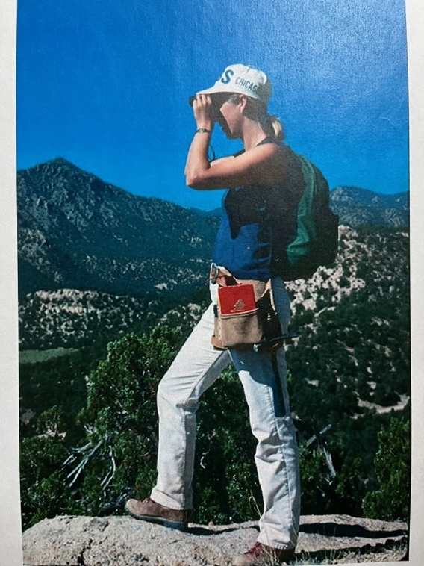
In addition to a backpack filled with gear, field geologists wear sturdy leather boots and long pants for protection from rocky, uneven terrane and scratches from walking through brush.

This field geologist is carrying her bright orange field notebook and geology hammer at her waist in a tool pouch for easy access.

Activity: Fossil Dig
Sort through real sediment to find read fossils.

Preparation
To accommodate more than one participant at a time, parcel out portions of the fossiliferous sediment into several shallow plastic trays.

Instructions
Invite participants to dig through the unsorted sediment, retrieve fossils, and set them aside, sorting by type (the ones that look similar). After collecting the fossils, invite participants to use their own words to describe the fossils (does it have holes? Bumps? Ridges?) then use the fossil identification guides to identify them as completely as they can.

Once an identification is made, participants then fill out a label (template, below) and place the fossil in the specimen bag with the label. Depending on your supplies and needs, participants may be invited to take a specimen home with them.

Materials
Unsorted fossils in sediment (see Resources list for sources)
Plastic tweezers
Shallow plastic trays or jar lids for placing sorted specimens
Fossil identification guide
zip-lock specimen bags
labels (see below; edit as useful; perhaps add your Library name/logo)
pencils
Geologic timescale chart

Specimen label template (example below)

Specimen number
Fossil ID
Locality
Age
Identified by
Date

Part II: Words from Professional Paleontologists

Reading: So you want to be a paleontologist. Advice to High Schoolers from a retired paleontologist.

Dear Aspiring Paleontologist,

In thinking about any career path it’s good to have a realistic idea of the sorts of jobs and training needed. Your assignment is to get online and search “jobs in paleontology” and see what’s out there and what training/degree is required. You need to know that there are many more people who want to be paleontologists than there are jobs in paleontology. There is a Facebook page for people looking for jobs in paleontology; it’s called “Unemployed/Underemployed Paleontologists”, which gives you an idea of the condition of the current job market. Check it out https://www.facebook.com/groups/PaleoJobs

Some people come to paleo through the biology side, classically, many people come to paleo through geology. Note, however, that many university “geology” departments are not called “geology” departments anymore; the emphasis is on the environment, as many entry level jobs with environmental firms are available for our graduates (cleaning up the messes we’ve made). Get online and study university websites. Make sure that whatever school you apply to has at least one paleontologist on the faculty and paleo courses for you to take!

The amount of schooling you need depends on your job aspirations. A position teaching paleontology at a college or university requires a Ph.D., which is 4+ years of schooling after your bachelor’s degree. There are museum jobs, like collections manager, that do not require a Ph.D.

Check jobsites for the state of Michigan and usajobs.gov. Here is a website chock full of information about being a geoscientist, jobs, etc.:
https://www.americangeosciences.org/workforce/career-resources

Finally, be flexible in your thinking. Few of us are able to map out our life’s path when we are HS seniors, and seldom is our life’s path a straight line from point A to point B. Stuff happens. In talking about the history of life, we call that ‘contingency’. In your case, it might mean to be flexible about what your idea of being a paleontologist entails—would you be happy teaching in K-12, finding ways to share your enthusiasm for paleontology in examples in reading, math, social studies, and science lessons? Another FB group to check out is the page for Michigan Earth Science Teachers, https://www.facebook.com/mestarocks

Would getting a job in another, unrelated area (the job that pays the bills) but volunteering in your spare time at museums or school science nights, joining an avocational fossil club or having a paleontology blog satisfy your ‘paleontology itch’? Those are questions only you can answer. And your answer to those questions may well change as you explore your path. It’s ok to change your mind; young people today are likely to change jobs many times, unlike your parents or grandparents who likely had one or two jobs as adults.

Wishing you the best as you set out on this adventure,
Dr. Danita Brandt, Associate Professor emerita, Michigan State University

Activity: Paleontologist Profiles

Instructions
Invite participants to view the paleontologist profiles on the Museum of the Earth (www.museumoftheearth.org/daring-to-dig/paleontologist-profiles) and/or American Museum of Natural History (https://research.amnh.org/paleontology/portraits/). Then create a posters featuring one the scientists and their discoveries.

Additional resources and videos for educators are available here: https://www.museumoftheearth.org/daring-to-dig/additional-resources/teachers

Topics include:
- What is Paleoart?
- What are Museums Even for?
- What are collections and why should you CARE?
- What do paleontologists wear?

Materials
Poster boards
Markers

Part III: What to do when you find a fossil

Reading: I found a fossil! (or did I?) The etiquette of asking professionals for help in identifying your finds. Advice from another retired paleontologist

You are walking along a creek bed when you see an oddly shaped and colored rock. You pick it up and think “this must be a fossil!” So, you immediately take a few fuzzy photos, email them to a professional paleontologist whose name you found online, and ask them to identify it. Maybe they will also tell how old it is and if it is worth anything! And just to be careful, you don’t tell them where you found it, except that “it was in a creek bed near my house.” I am here to tell you that when the paleontologist responds, they will applaud your curiosity but inform you that you have not given anywhere near enough information to make any kind of identification. Like when you go to the doctor or auto mechanic, the more information you have ready in advance, the better the interaction. So, as a service to both interested members of the public and my fellow paleontologists, here are some suggestions of what to do before you seek a professional opinion.

- Carefully record where the specimen came from. Include as detailed a geographic description as possible, at least to the level of county or nearest town. This allows the paleontologist to determine what bedrock is present in the area. It is also proper collection practice; a specimen of unknown geographic origin (“provenance”) is virtually useless.
- Write a description where the specimen was found. Did you inherit it? Was it loose in a stream bed? Hammered out of a rock formation? Picked out of road gravel? In the middle of a cornfield? It is important to know if the specimen can be directly associated with the bedrock in the area. If possible, photograph the site.
- Take sharp photographs of the specimen with different lighting and orientations; they should fill the frame. Natural light is best. If possible, take close-ups. Always include a clear scale [ruler].
- This is a great opportunity to learn about fossils and paleontology. Do some background reading on fossils and fossil preservation. Your public library should have some basic books on the subject, such as the classic Golden Guide to Fossils, Smithsonian Handbooks: Fossils, or the National Audubon Society Field Guide to North American Fossils. You may see your fossil, or something very much like it. Pay special attention to the sections on how fossils are formed.

If you prefer looking online, high-quality websites include: Time Scavengers and the Museum of the Earth.

- It is also worth learning about objects that look like fossils but are not (“pseudofossils”). Probably the most common of these are concretions. If it looks like a foot [or a brain or a heart] it is probably a concretion.
- Investigate the geology of your area. Every state has a geological survey which has made maps and published descriptions of local regions; these often contain descriptions of what fossils were found there. Knowing what rocks are present where the fossil was found will help constrain the identification (if your rocks are Ordovician, you cannot have a dinosaur!)
- Some of the most knowledgeable experts on fossils in an area are the members of local fossil clubs (for a list, see: myFOSSIL). Bring your specimen to a club meeting, there will be people there eager to help you identify your find and share their knowledge. They will also advise on best collection practices and how to interact with professionals. Many fossil clubs, as well as natural history museums, run fossil identification days where you can bring your specimen. If it is something unusual, you will be urged to bring it to a professional’s attention.
- There are also fossil groups on Facebook, many tied to periods of geologic time. You can share your pictures there to get opinions, although they are not always well-informed.
- The Paleontological Society has a Fossil ID site where you can submit information about your find to a group of volunteer experts. Read and follow the instructions!

A few more things. Don’t expect an immediate response to an email or letter. Although interacting with the public is integral to what we do, paleontologists have full time jobs, with many demands on their time. For the same reason, do not show up unannounced. Send an email first, with the information discussed above. If the specimen is of interest, you will be invited to make an appointment.

Be prepared to hear that you’ve found something common, that it’s not a fossil at all, or that it’s not even a natural rock. And please don’t start an argument over this; you asked for a professional opinion, and you received it. If you don’t agree, then feel free to ask elsewhere.

Ethically, a professional paleontologist will not make an appraisal of monetary value. The buying and selling of fossils is a sore subject among my colleagues and we do not want to encourage it. On the other hand, there is chance that the specimen is of scientific interest. In that case, you may be asked to consider donating the fossil to a museum collection. If it is really unusual, it may become the subject of a scientific paper!

It is wonderful that you found a fossil. If you do your homework, you will learn a lot about paleontology and history of life on Earth. And you will get a chance to interact with the community of avocational and professional paleontologists, who will be glad to welcome a new knowledgeable enthusiast.

--Dr. Roy Plotnick, Professor emeritus, University of Illinois at Chicago, 2021.

Materials List

Item | Supplier/Information
Field paleontology
Backpack
field notebook | Rite-in-the-Rain, see Resources
safety glasses
hard hat
safety vest
collecting bags (zip-lock)
marking pen
ruler or other scale | A scale marked in centimeters is preferred to inches
hand lens (magnifying glass)
Lunch or snack
maps
hat
sunscreen
Work (leather) gloves
first-aid kit with essentials | Size is a consideration. A zip-lock bag with essentials* is more realistic than a bulky full-sized kit. *Band-aids, antibiotic ointment, tweezers
rock hammer (if age-appropriate) | Many rock hammers have a sharp point which is not advisable to use for this demonstration. A “bricklayers” hammer with a broad end is safer; safer yet is a carboard cut-out of a hammer.
newspaper for wrapping fossils
Snack-size zip-lock bags
Fossil Dig
Unsorted fossils in sediment | See Resources for suppliers
Plastic tweezers
Shallow plastic trays jar lids
Fossil identification guides | The Golden Guide Fossils (see Resources for full info)
Permanent marker
Snack-size zip-lock bags
Specimen labels | Sample template is included in the activity description
Geologic timescale chart | See Resources for website ordering info

Resources

“Fossil Dig” sets

Best bet
Partner with your local rock/mineral/fossil club for help in assembling a set

Commercial vendors
Availability from commercial vendors is highly variable.

Current availability as of December 2025
https://foxyfossils.com/products/fossil-dig-kits

This site offers bulk shark teeth: https://www.prehistoricstore.com/

Geology Field notebooks
Rite-in-the-rain https://www.riteintherain.com/3x5-top-spiral-notebook#135

Geologic time chart

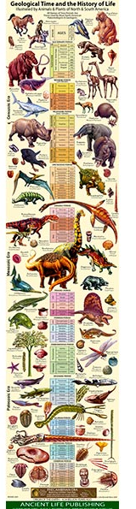
Color poster with illustrations of plants and animals through time (see photo, belo)
https://www.petrifiedforestbookstore.com/shop/books/children/geological-timeline-and-the-history-of-life/

