Unearth a Story, II: Fossils are clues to the past
What fossils can tell us about ancient life and environments

Dr. Danita Brandt and Dr. Katie Maloney, Department of Earth & Environmental Sciences, Michigan State University, East Lansing MI brandt@msu.edu; malonekm@msu.edu

Questions explored: How can fossils be used to “tell time”? How much is a million years? How big is a billion years? How can rocks and fossils tell us about how environments have changed through time? How has Michigan changed over its geologic history?

Part I: How can fossils tell us about time? 2
Background 2
Activity: Introduction to the Geologic time scale and the major divisions (Eras, Periods). This activity is divided into three levels: 2
Instructions 2
Materials 2
Activity: Constructing a Geologic timeline to scale 2
Outdoor Instructions 2
Materials 4
Part II: How much is a million? How big is a billion? Conceptualizing Really Big Numbers and Really Long Periods of Time 6
Background 6
Activity: One million dots 6
Description 6
Instructions 6
Materials 7
Activity: How Big is a Billion? 7
Description 7
Part III: Michigan’s environments through time 9
Background 9
Activity: Michigan’s geologic history 9
Preparation 9
Materials 9
Activity: Build a Diorama showing Michigan’s geologic history 9
Description 9
Instructions 10
Materials 10
Reading: A story of fire, water and ice 12
Resources for these activities 13
Materials List 19
General Paleontology Resources 21

Part I: How can fossils tell us about time?

Background
The geologic timescale was constructed based on the fact that different plants and animals lived at different times. We find fossils in a definite, recurring order in the rocks that preserve them, what geologists refer to as “The Principle of Faunal Succession”.

Activity: Introduction to the Geologic time scale and the major divisions (Eras, Periods). This activity is divided into three levels:
Using the geologic timescale and dinosaurs as a benchmark we can construct a simple chronology (“before dinosaurs” and “after dinosaurs”).

Instructions
Participants will be invited to sort the plants and animals to their proper place along the timeline and familiarize themselves with the major divisions, the Paleozoic Era (“ancient life”), Mesozoic Era (“middle life”) and Cenozoic Era (“dawn” or “new” life). Participants will probably recognize that dinosaurs are found in the Mesozoic Era (which consists of the Triassic, Jurassic, and Cretaceous Periods).

Materials
Illustrated geologic timeline (see Resources list)
Geologic timeline coloring sheet (below)
Model fossil plants and animals or drawings (see Resources list):
dinosaur
mammoth or other ice-age animals trilobite
corals (including Petoskey Stone) brachiopods snails petrified wood etc.

Activity: Constructing a Geologic timeline to scale
We will use a scale of 1 cm = 1 million years (1,000,000 years). We need to measure the ages back to 4.6 billion years (4,600,000,000 years) so your timeline will be a whopping 4,600 cm, or 46 meters long. We will need a big floor for measuring.
Included are instructions for an outdoor version (total length 383 feet) and an indoor version (total length 4.6 meters).

Outdoor Instructions
Outdoor version
Use the scale of 1‘ = 1 million years for a total length of about 383 feet.

Create the Timeline
Step 1: Measure 46 meters of tape and sidewalk. Mark the start and finish lines.
Step 2: Using the timeline (below) make a number of scale marks on your timeline (marked in bold) along the paper trail at the scaled‑off distances.
Step 3: Fill in the intervals with major and minor events.
Step 4: Walk through the finished timeline from origin of the Earth to today. Note how much time passes before some life appears!

Outline of Events
Starting line: 4.6 billion years — Origin of the Earth
Draw: Meteorite impact, volcanic eruptions, hot springs
Measure 8 m to the next boundary
3.8 billion years — earliest life (one‑celled algae)
Draw: First one‑celled organisms (algae) or strips from chains or filaments; laminated layers on seafloors with cabbage‑like layers.
Measure 3220 cm or 32.2 m to the next boundary
580 million years — earliest multicellular life
Draw: jellyfish, 'worms', algae (no shells or hardparts)
Measure 35 cm to the next boundary
545 million years — 'Cambrian explosion'; fossils appear
Draw: trilobites, snails, clams, brachiopods, crinoids, squid (all sea‑dwelling, no vertebrates or land animals)
Measure 105 cm to the next boundary
440 million years
Draw: fish with bony armor
Measure 12 cm to the next boundary
428 million years — earliest land plants
Draw: simple branching plants, ferns (no flowers or deciduous leaves)
Measure 48 cm to the next boundary
380 million years — earliest land animals
Draw: spiders, scorpions, centipedes
Measure 135 cm to the next boundary
245 million years — Age of dinosaurs
Draw: dinosaurs, pterosaurs, plesiosaurs, ichthyosaurs
Measure 180 cm to the next boundary
65 million years — Age of mammals & flowering plants
Draw: many mammals (shrews, horses, camels, whales, rhinos, etc.); flowering plants; deciduous trees; insects
Measure 64 cm to the next boundary
1.5 million years — Ice Age
Draw: mammoths, mastodons, saber‑tooth cats, giant sloths (Note: won’t fit well in the space!)
1 million years — Humans appear
You only have 1 cm for this!
Measure 1 cm to the next boundary
Finish Line: Today

Materials
100’ (or metric) tape measure sidewalk chalk (outside version)
Take-home coloring sheet version of the timescale
register tape and markers (indoor version) Take-home coloring sheet version of the timescale

Preparation
Measure and mark the major boundaries beforehand. Participants can then fill in the spaces with drawings of representative events/lifeforms of each main interval (see appendix).

Rainy day version (indoors)
Use a scale of 1 mm = 1 million years (4.6 meters long, total)

When drawings are completed, walk back to the beginning of the timeline and walk through it (forward in time) recapping the main events.
Create the timeline:
Step 1: Lay out 4.6 meters‑long paper trail on the floor.
Step 2: Use the outline (below) to mark off the different event boundaries (marked in bold) along the paper trail at the scaled off distances.
Step 3: Fill in the intervals with appropriate plants, animals, and geologic features (examples are listed to get you started)
Step 4: Walk through the finished timeline from origin of the Earth to today. Note how much time passes before animal life appears!
Outline of Events
Starting line: 4.6 billion years — Origin of the Earth
Draw: Meteorite impacts, volcanic eruptions, hot springs
Measure 80 cm to next boundary.
3.8 billion years — earliest life (one‑celled algae)
Draw: one‑celled organisms (these can be linked up to form chains or filaments); algal stromatolites (laminated sheets or domes with cabbage‑like layers)
Measure 322 cm to next boundary.
580 million years — earliest multicellular life
Draw: jellyfish, “worms”, algae (note: no shells or hardparts!)
Measure 3.5 cm to next boundary.
545 million years — shelly fossils appear
Draw: trilobites, snails, clams, brachiopods, corals, squids; algae and soft‑bodied animals are still around (note: all these critters still live in the sea! No vertebrates or land dwellers)
Measure 10.5 cm to next boundary.
440 million years — earliest vertebrates
Draw: these were fish with bony armor
Measure 1.2 cm to next boundary.
428 million years — earliest land plants
Draw: simple branching plants, ferns (note: no flowers or deciduous leaves!)
Measure 4.8 cm to next boundary.
380 million years — earliest land animals
Draw: spiders, scorpions, centipedes
Measure 13.5 cm to next boundary.
245 million years — Age of dinosaurs
Draw: dinosaurs, pterosaurs, plesiosaurs and ichthyosaurs (marine reptiles)
Measure 18 cm to next boundary.
65 million years — Age of mammals and flowering plants
Draw furry mammals: shrews, horses, camels, wolves, rhinos, etc.
Also: flowering plants, deciduous trees, birds, & insects
Measure 6.4 cm to next boundary.
1.5 million years — Ice Age
Draw mammoths, mastodons, sabertooth cats, giant sloths
Note: this won’t fit very well in the space allotted!!!
Measure 1/2 mm to next boundary.
1 million years — Humans appear
You only have 1 mm for this!
Measure 1 mm to next boundary.
Finish Line: Today

Additional resources: See Resources at the end of this document
International Commission on Stratigraphy chart (downloadable and printable). This is a ‘living document’ that is continually updated. https://stratigraphy.org/chart/

The Geological Society of America has a North American geologic time chart (some names differ from the international version. Search for Geological Society of America timescale for a downloadable pdf.
National Parks coloring sheets can also be placing along the Geologic Timeline (see resources at the end for link to free coloring pages).

Part II: How much is a million? How big is a billion? Conceptualizing Really Big Numbers and Really Long Periods of Time

Background
Geologists commonly talk about millions and billions of years ago very casually, but these are very large numbers that are hard to truly understand. Putting it in human terms: we live about 100 years, our parents 100, grandparents 100, that gets our understanding of family history back 300 years…still 700 years from a thousand, and 17000 from a million and 17,000,000 from a billion! How can we humans, whose written history goes back thousands of years, understand thousand

We are going to use several different analogies to try to understand just how big these numbers are.

Activity: One million dots

Description
We are going to try to make one million dots. (This activity could be run over the course of an hour, a day, or be a continuing activity for the duration of the summer program).

Instructions
Invite participants to use the markers to make dots on the paper (this could be one very large piece of paper or individuals can contribute single pages to be aggregated). Instruct participants to make their dots in groups of 100 so we can count them easily. Allow individuals to work as long as they care to or set a time limit and then tally their dots. Collect their page and add to the collective results. At the completion of the exercise, tally the dot count and invite participants to discuss the results:

As a group or individually, take the dot total and subtract from one million to get the number of remaining dots required to reach one million. Divide that number by the day’s dot total to get the number of additional days required to get to 1 million dots (that is assuming the same number of participants working for the same length of time. For example, a daily total of 32,000 dots gives a remainder of (1,000,000 - 32,000 = 996,800). 996,800 divided by 32,000 is 311 years.

Keep track of each day’s dot yield and post a running total along with the number of dots remaining to reach the goal by the end of the program (be that a day, a week or the entire summer). Note: some participants get obsessive about this task and may need to be relieved of duty!

Supplement the discussion with reference to the examples described in How Much is a Million

Materials
Paper
Markers
Calculator
How Much is a Million, by David M. Schwartz and Steven Kellogg

Activity: How Big is a Billion?

Description
After wrestling with the task of making one MILLION dots, invite participants to contemplate how much time it would take to make ONE BILLION dots, then consider the fact that the age of the Earth is about 4.6 times that number (4.6 billion years old).

To help conceptualize how big a billion is, start with 1 and increase by powers of ten (x10) 1
10 = 1 with 1 zero (10¹)
100 = 1 with 2 zeros (10²)
1,000 = 1 with 3 zeros (10³)
10,000 = 1 with 4 zeros (10⁴)
100,000 = 1 with 5 zeros (10⁵)
1 million = 1,000,000 = 1 with 6 zeros (10⁶)
10 million = 10,000,000 =1 with 7 zeros (10⁷)
100 million = 1 with 8 zeros (10⁸)
1 billion = 1 with nine zeros, (10⁹) or 1,000 times a million (10³x10⁶ = 10⁹)

Supplement the discussion with reference to the examples described in How Much is a Million. Other resources for thinking about big numbers are listed in “Resources”.

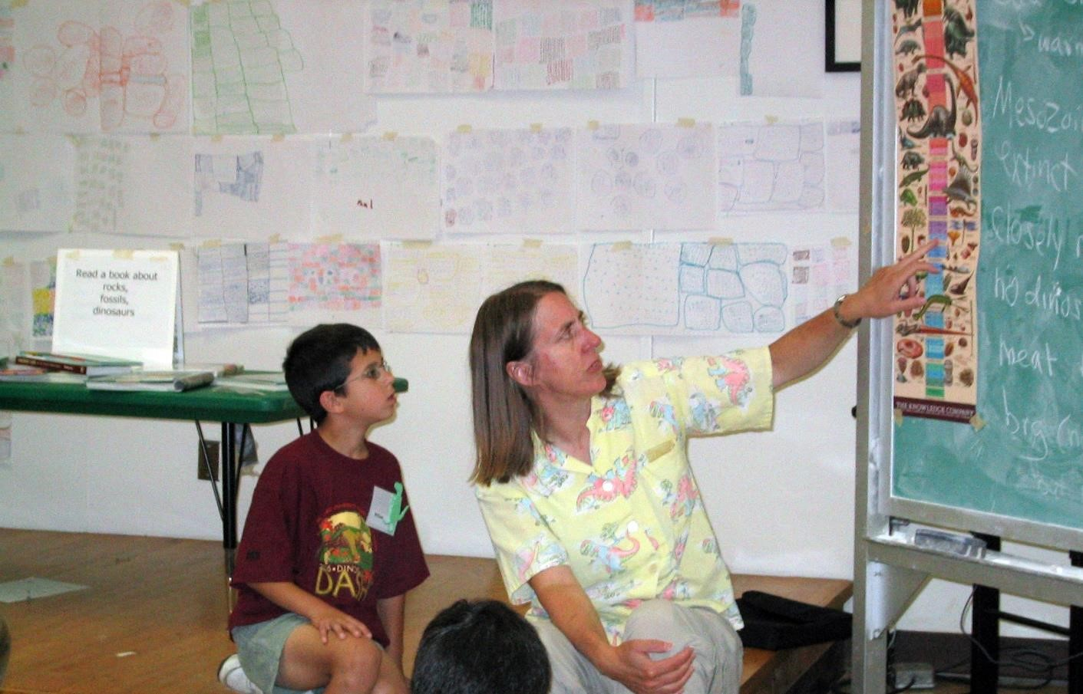
Fossil Camp Director Danita Brandt and camper William Burke discuss the geologic time scale in front of a wall papered with the Million Dots project. MSU Museum 2007.

Part III: Michigan’s environments through time

Background
The type rocks and fossils we find tell the story of the environment in which they formed. For example, sandstone is made of sand (duh!) deposited in an environment that deposits sand (double duh).that In Michigan, the rocks and fossils:

Michigan when it was covered by an ocean
Michigan when there were coal swamps
Michigan during the last ice age

Activity: Michigan’s geologic history

Preparation
Read Danita Brandt’s 400-word summary of Michigan geology
((https://spartan.msu.edu/spartan-story-hub/news/2014/10/faculty-voices
Watch Danita’s YouTube video on Michigan geology https://www.youtube.com/watch?v=mOxWRhyZcvQ&t=275
Copy is reproduced, below.

Materials
Coloring sheet handout of Michigan’s geologic history (see appendix)
Rocks and fossils from when Michigan was covered by a shallow, tropical ocean Marine fossil (Petoskey stone, other coral, brachiopod, etc.)
Rocks and fossils after the seas drained away and there were coal swamps in Michigan
Plant fossil
Coal (formed in coal swamp from pant material)
Sandstone (ancient fossil beach near the coal swamps)
Fossils from the last ice age (Pleistocene Epoch), animals that lived in Michigan between glacial advances (plants and animals were pushed south as glaciers advanced): Model mammoth or mastodon or other ice age mammal (note: there are no sabretooth tigers known from Michigan, but we have a lot of mammoths and mastodons)

Activity: Build a Diorama showing Michigan’s geologic history

Description
We will make a mini-museum of shoebox dioramas showing the life and environments of Michigan during its earliest history, when Michigan was covered by a shallow, tropical ocean in which various marine critters lived (including our Petoskey Stone coral), a second diorama representing the coastal coal swamps that left behind fern fossils and coal, and a third diorama showing the animals that lived in Michigan between glacial advances during the most recent ice age of the Pleistocene Epoch.

Instructions
Consult resources like the Michigan Fossil Packet and the coloring booklet “Michigan…” for ideas of what plants and animals to include in each diorama

Materials
A shoe box for each diorama
photos/posters/books showing life of the past during each episode in Michigan’s history paper trilobite model (see appendix) paper nautiloid model (see appendix)
Appropriately sized animals for each diorama, e.g. Toob “Prehistoric Life” set (see appendix)
construction paper in a variety of colors glue/glue sticks pipe cleaners string or thread various other materials as inspiration reveals (e.g., Cheerios for crinoid stems); paper models (see appendix); a large box for each diorama constructed.

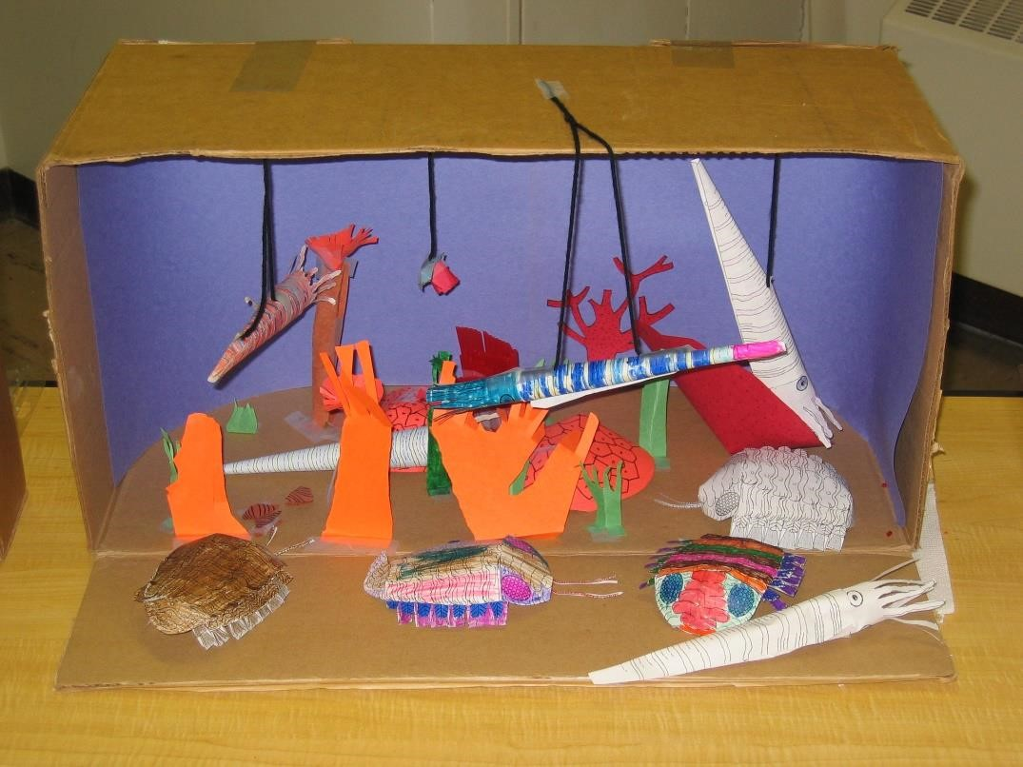
Diorama of Michigan as it appeared during the Early Paleozoic Era, covered by a shallow, tropical sea inhabited by trilobites, corals, cephalopods, and more.

“Raw” Petoskey Stone coral Hexagonaria. White bar scale is 1 cm. Photo may be reproduced for non-commerical or educational use. Please credit photographer Danita Brandt.

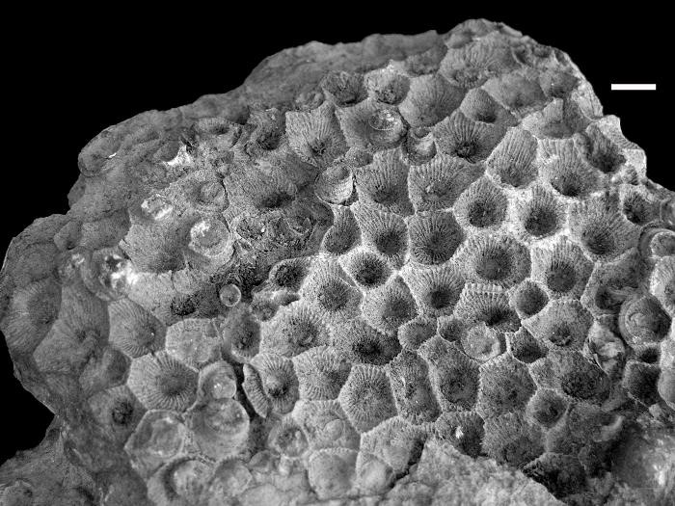

Polished Petoskey Stone coral Hexagonaria. White bar scale is 1 cm. Photo may be reproduced for non-commerical or educational use. Please credit photographer Danita Brandt.
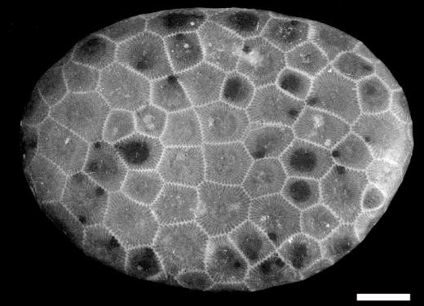

Reading: A story of fire, water and ice
[note: because of the 400-word limit, the explanation for why we have no dinosaurs in Michigan is not included. See the YouTube video for the full story]

Danita Brandt
Associate Professor, emerita
Department of Earth & Environmental Sciences, Michigan State University (originally written for the Lansing State Journal “Michigander” feature)

If you are like most people, you probably take for granted the earth beneath your feet. After all, it’s just boring rocks and dirt, right? I have 372 words remaining in which to encourage you to look more closely at the landscape and rocks around us, because every rock tells a story.

Michigan’s geologic story is one for the textbooks, because few other states have a geologic history as long and varied as Michigan’s. Our story begins a mind-bending 3 billion years ago, in what is now Michigan’s Upper Peninsula. We would not recognize the place—collision of tectonic plates in the Iron Country triggered volcanic eruptions and mountain building. Ancient pillow basalts from these volcanoes— like those forming on the seafloor off the coast of Hawai’i today-- can be seen in Marquette. Michigan’s iron ore, later to become the backbone of our auto industry, was a product of those tectonic upheavals.

A billion years later, the area we know as the Keweenaw Peninsula was the site of tectonic plates pulling apart, or rifting. The magma that welled up from earth’s interior along the fractures generated by rifting was rich in copper, the mineral that would define the economy of our state eons after the last tectonic plate ground to a halt.

Flash forward 2 billion years, and we see Michigan covered by a shallow, tropical sea. How do we know? Our state icon, the Petoskey stone, is a fossil coral, a denizen of that long-vanished sea, along with other marine invertebrates like clams, snails, and the extinct trilobites. Detroit’s salt and Grand Rapids’ gypsum formed in this shallow sea. Over the millennia, billions of microscopic plankton accumulated on the sea floor, forming petroleum-rich shale that we now tap to fuel our cars.

As the sea drained away from Michigan, ferns and other plants grew near coastal swamps, eventually to become the coal beds of Fitzgerald Park in Grand Ledge.

In the last chapter of our story, geologically “only yesterday”, glaciers waxed and waned, leaving rocks and boulders imported from Canada as their calling cards, including “The Rock” at MSU. Glaciers sculpted our modern landscape and gave “The Mitten State” our identity—they deepened and widened ancient river valleys to form the Great Lakes. The story of how Michigan was born of fire, water, and ice is hardly boring! And it’s written in the rocks under our feet.

Resources for these activities

The following two pages are the template for the coloring brochure on Michigan’s ancient environments, “What Michigan looked like millions of years ago”. Feed the following two pages into a printer and make two-sided copies, then fold the page in half to make a 4-page brochure.

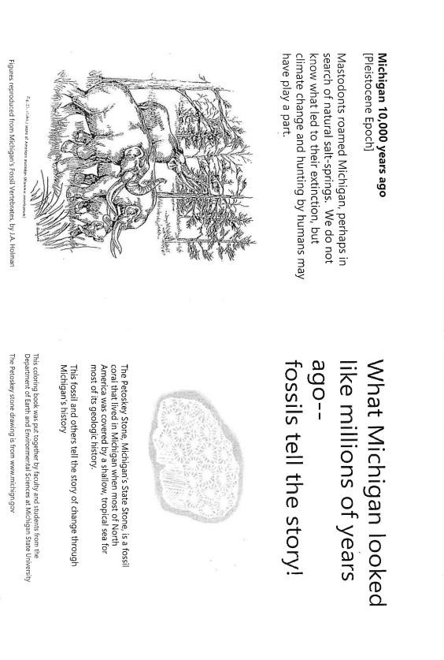

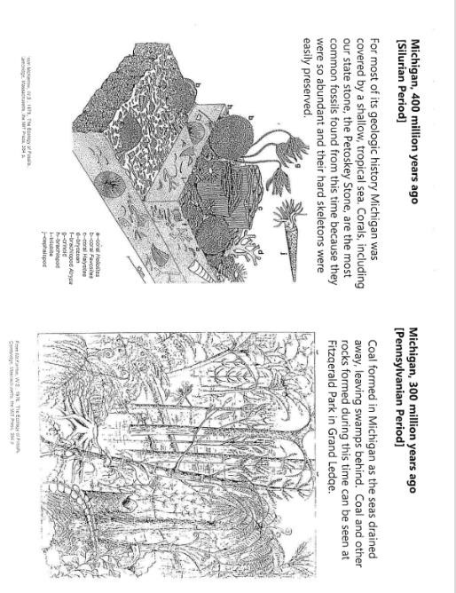

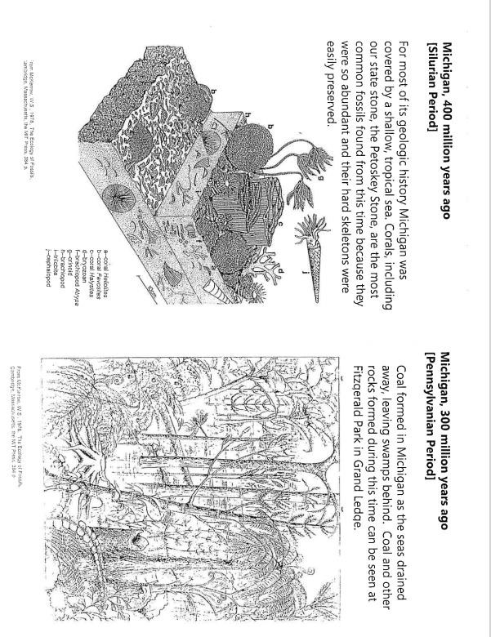

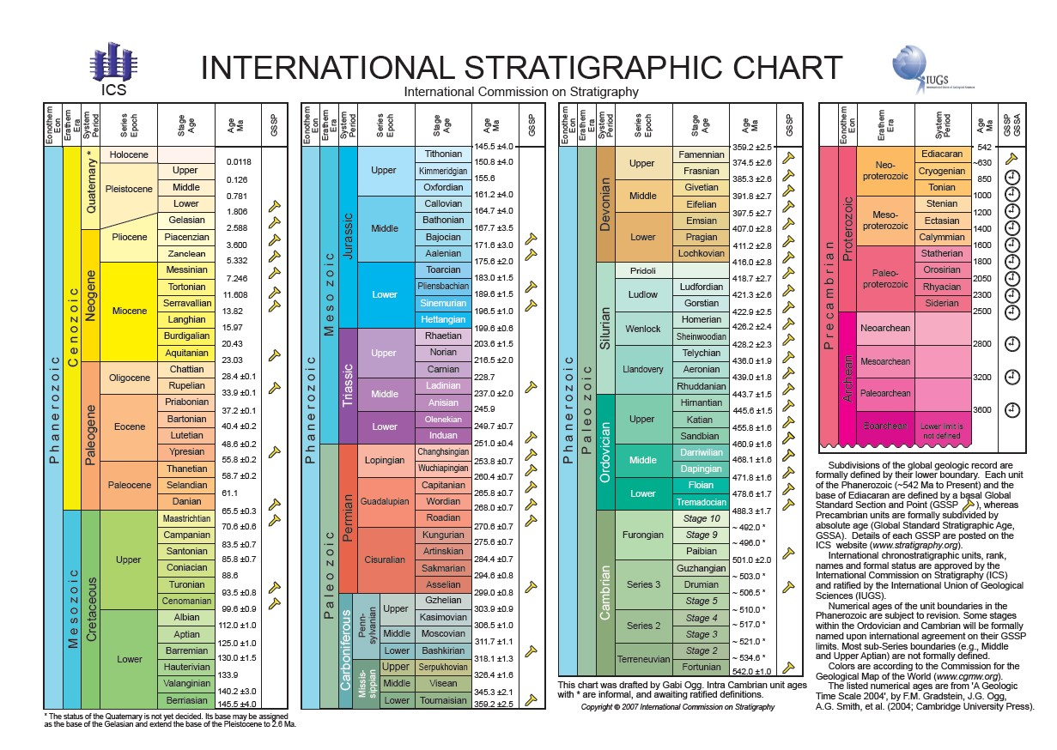

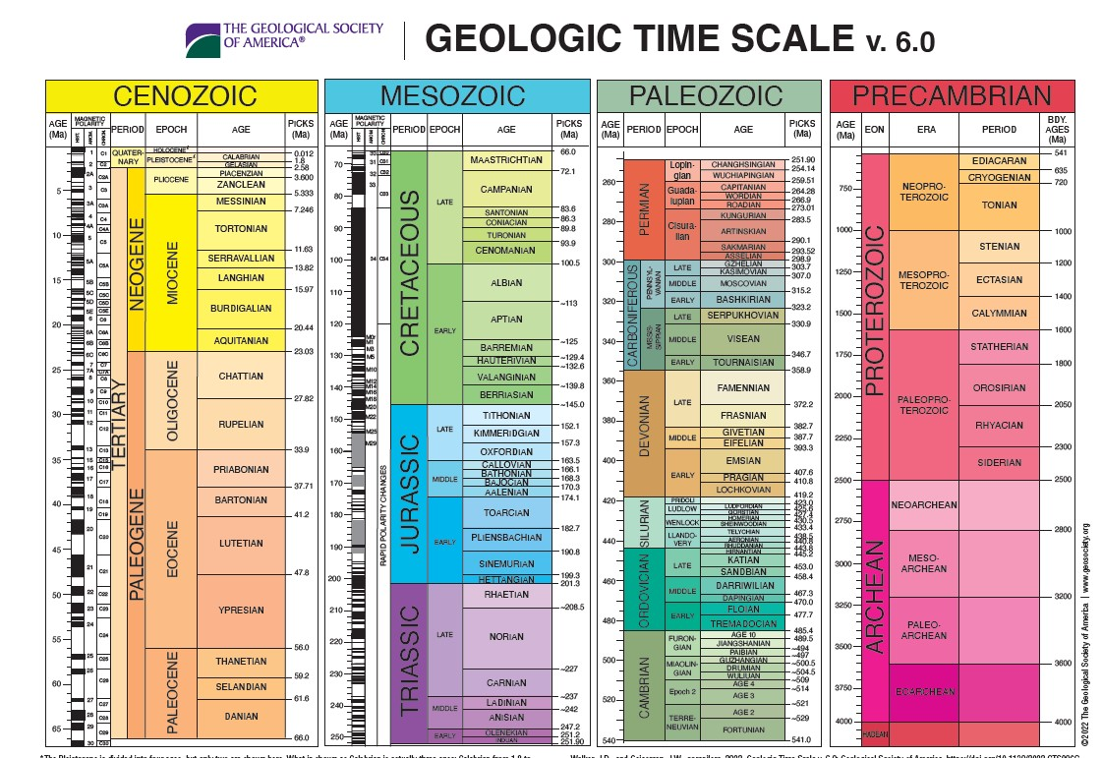

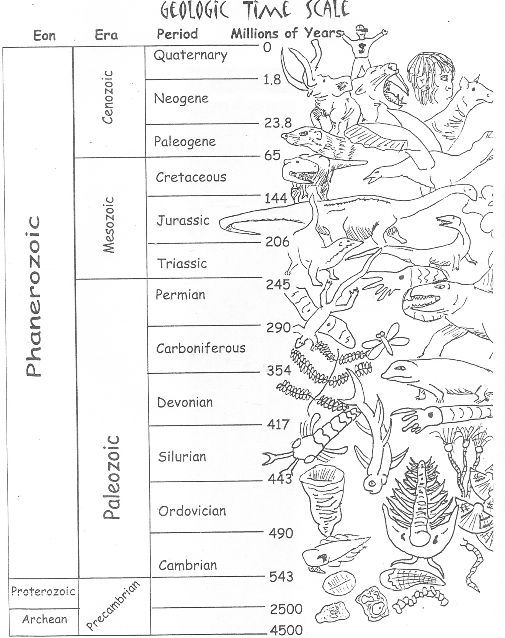

Drawing by Lisa Whitenack. Permission for reproduction is granted for non-commercial, educational use. Please credit the artist.

Materials List
Activity/Items | Supplier/Information
Introduction to the Geologic Time Scale
Illustrated timescale | See “Resources”, below for ordering information
Geologic timescale coloring sheet | Template, below
Drawings of plants and animals from different geologic periods | National Park Service website, see Resources, below
Fossils | See Resources for sources of fossils and fossil models
Draw a timeline to scale
100’ tape measure
Sidewalk chalk
Register tape
markers
Meter stick for indoor version
Geologic time coloring sheet
Big numbers activity
Felt-tip markers
A lot of blank paper
Build a Diorama
Shoeboxes (or larger boxes if more ambitious!)
construction paper in variety of colors
Scissors
Natural sponge
Clam shells
Cephalopod paper model | See template, below and website for ordering originals
Trilobite paper model | See template, below and website for ordering originals
Models of plants and animals from different geologic periods | See Resources, below
Glue sticks
Tape
pipecleaners
Thread or string
Coloring brochure on Michigan environments through time | See template, below
Michigan Fossils Poster Pack | See Resources for website address

General Paleontology Resources
Paper trilobite and cephalopod models are available through https://www.nps.gov/subjects/fossils/educational-activities.htm

National Parks Coloring book of plants and animals through time https://www.nps.gov/subjects/fossils/coloring-book.htm

More information on various aspects of geology and paleontology from National Parks Service website Fossils and Paleontology
https://www.nps.gov/subjects/fossils/fossils-through-geologic-time.htm

Toob set of “Prehistoric Life” includes ice-age animals, including humans

Envisioning really big numbers:
https://cdn.serc.carleton.edu/files/quantskills/methods/JohnsonBigNumbers.pdf

Geologic time charts
Color poster with illustrations of plants and animals through time (see photo, belo) https://www.petrifiedforestbookstore.com/shop/books/children/geological-timeline-andthe-history-of-life/

International Commission on Stratigraphy (downloadable and printable) (see photo, below) https://stratigraphy.org/chart/

The Geological Society of America North American version of the geologic time scale (photo, belo)
Search for “Geological Society of America timescale” for a downloadable pdf

Information on Michigan’s fossils and geologic history
Danita Brandt’s 400-word summary of Michigan geology (reprinted below) https://spartan.msu.edu/spartan-story-hub/news/2014/10/faculty-voices

Danita’s YouTube video on Michigan geology (1 hour)
https://www.youtube.com/watch?v=mOxWRhyZcvQ&t=275

Michigan Fossils poster pack, downloadable pdfs. Search on “Michigan Fossils Poster
Pack” or use the link https://www.michigan.gov/-
/media/Project/Websites/egle/Documents/Programs/GRMD/Catalog/10/MFP-1b-
Poster-Big.PDF?rev=90214e3f65aa4c0c94152138dee0e8d2

For help in obtaining rocks and fossils
Contact local rock and mineral clubs for help in obtaining free or low-cost Michigan fossil kits. An online directory is available at https://www.geology365.com/club-directory/state/Michigan

For commercial sources of rocks, minerals, and fossils: search on “Michigan rock shops”

