Unearth a Story, III: Dinosaurs
What fossils can tell us about ancient life and environments

Dr. Danita Brandt and Dr. Katie Maloney, Department of Earth & Environmental Sciences, Michigan State University

Questions explored: What is a dinosaur? When did dinosaurs live? How big were dinosaurs? Why do we think dinosaurs and birds are closely related? Telling behavior and diet from teeth and claws. How is dinosaur bone different from bones of living animals? How are dinosaur fossils preserved? Where did dinosaurs live? Are there dinosaurs in Michigan? Where can I go to see dinosaurs?

Part I: What is a dinosaur? 2
Background 2
Instructions 2
Materials 3
Activity: How big were dinosaurs? 3
Description 3
Instructions 3
Materials 3
Activity: When (how long ago) did dinosaurs live? [One million dots!] 4
Instructions 4
Materials 5
Activity: How is a dinosaur bone similar and different from a ‘modern’ bone? 7
Instructions 7
Materials 7
Demonstration: How are dinosaur bones fossilized? 8
Materials 8
Part II: Birds and Dinosaurs 9
Background 9
Activity: Why do we think dinosaurs and birds are closely related? 9
Description 9
Interaction 9
Materials 9
Part III: Dinosaur Paleoart 11
Background 11
Activity: Why have our ideas of what some dinosaurs looked like changed? 11
Instructions 11
Materials 11
Part IV: Dinosaur Teeth and Claws 14
Background 14
Activity: Dino Digestion-- In one end and out the other (gastroliths and coprolites) 14
Instructions 14
Materials 14
Activity: What did the dinosaur use this for? (dino teeth and claws) 15
Background 15
Activity: Dino Digestion-- In one end and out the other (gastroliths and coprolites) 15
Instructions 16
Materials 16
Part V: Why are there no Dinosaurs in Michigan? 17
Activity: Dinosaurs in Michigan are found only in museums 17
Background 17
Instructions 18
Materials 18
Part V: The End. How did dinosaurs go extinct? 21
Activity: How can we know what caused extinction millions of years ago? 21
Background 21
Instructions 21
Materials 22
Materials List 23
General Paleontology Resources 24
Websites 24
Books (classics) 25

Part I: What is a dinosaur?

Background
Dinosaurs were reptiles, but not all reptiles are dinosaurs. As far as we now know, there are no dinosaurs that flew and none lived adapted for life in the water (there are some dinosaurs that have been interpreted as swimming but they were probably primarily land-dwelling).

Common misconceptions about what animals are dinosaurs include other ancient reptiles, like the flying reptiles (including pterodactyls), marine (ocean-living) reptiles (like mosasaurs and plesiosaurs) and the mammal-like, sail-back reptile Dimetrodon.
Dinosaurs can be divided into two group on the basis of different hip construction (the so-called ‘bird-hipped’ or ornithischians and the ‘lizard hipped or saurischians). Despite these names for hip-type, it is the lizard-hipped saurischians that may be closely related to birds (see Archaeopteryx activity, below), so birds can be considered direct descendants of dinosaurs and therefore, living dinosaurs!

Instructions
Sort the various animal models into groups (ideally, dinosaurs, mammals, birds, reptiles, amphibians). Describe characters that distinguish each group (for example mammals have fur/hair). Some characters are variable, for example, there are bipedal and quadrupedal mammals, so there may not be a single character that is useful for separating all the animals based on the models (without having DNA, for example!).

Materials
Set of dinosaur models and models of other animals, including birds, mammals, and reptiles.

Activity: How big were dinosaurs?

Description
By comparing our own foot to outlines of dinosaur feet we can estimate how much bigger (or smaller!) different dinosaurs were.

Instructions
Invite participants to trace their footprint or handprint on a piece of paper and then cut out their print and place their cutout next to the dinosaur footprints. Use their cutout to measure the length of the dinosaur footprint, that is, “how many of your foot/hand prints would fit inside the dinosaur footprint.?”

Invite participants to use their answer to estimate how big the dinosaurs were compared to them (note: we aren’t looking for a precise or even accurate answer, but as a talking point inviting them to think about how they might estimate the size of the dinosaur).

Materials
Cardboard template of dinosaur footprints, big and small (see appendix)
Paper to trace footprint or handprint
Pencil to trace footprint or handprint
safe scissors for cutting out the footprint/handprint
Dinosaur footprint model (https://www.istockphoto.com/vector/dinosaur-paw-monster-lizard-footprint-dino-black-silhouette-footstep-t-rex-fossil-gm1934507383-556179057)
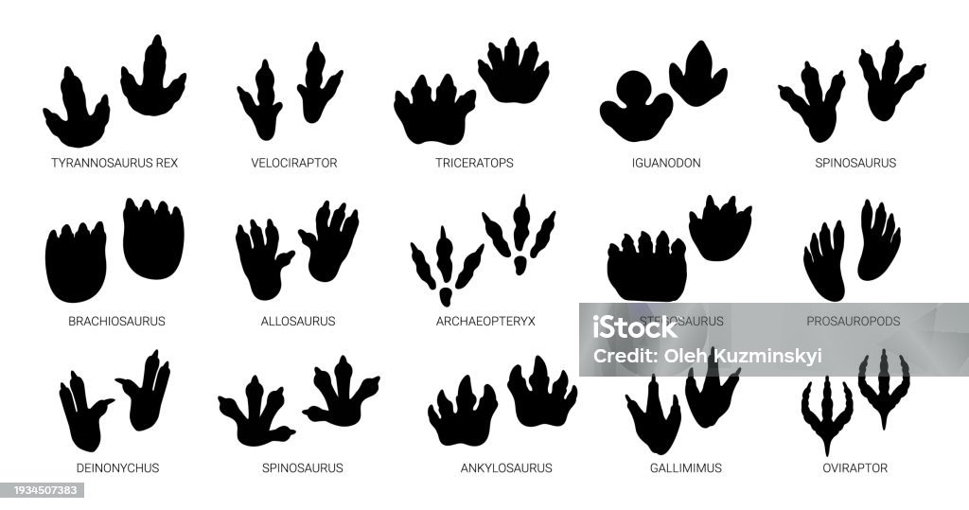

Activity: When (how long ago) did dinosaurs live? [One million dots!]

Background
Geologists commonly talk about millions and billions of years ago very casually, but these are very large numbers that are hard to truly understand. Putting it in human terms: we live about 100 years, our parents 100, grandparents 100, that gets our understanding of family history back 300 years…still 700 years from a thousand, and 17000 from a million and 17,000,000 from a billion! The earliest dinosaurs are known from about 240 million years ago and the last (non-bird) dinosaurs went extinct about 60 million years ago. One way to try to understand how big these numbers are is to try to make a million dots.

Instructions
Invite participants guess how long ago dinosaurs (not including their modern relatives, birds) lived. Look up the Mesozoic Era on the geologic timescale to find the age for the beginning of the Mesozoic Era and the end of the Mesozoic Era (these dates will differ slightly from different sources as age dates have been refined over the years). We are going to try to make one million dots. (This activity could be run over the course of an hour, a day, or be a continuing activity for the duration of the summer program).

Use markers to make dots on the paper (this could be one very large piece of paper or individuals can contribute single pages to be aggregated). Instruct participants to make their dots in groups of 100 so we can count them easily. Allow individuals to work as long as they care to or set a time limit and then tally their dots. Collect their page and add to the collective results. At the completion of the exercise, tally the dot count and invite participants to discuss the results:

As a group or individually, take the dot total and subtract from one million to get the number of remaining dots required to reach one million. Divide that number by the day’s dot total to get the number of additional days required to get to 1 million dots (that is assuming the same number of participants working for the same length of time. For example, a daily total of 32,000 dots gives a remainder of (1,000,000 - 32,000 = 996,800). 996,800 divided by 32,000 is 311 years.

Keep track of each day’s dot yield and post a running total along with the number of dots remaining to reach the goal by the end of the program (be that a day, a week or the entire summer). Note: some participants get obsessive about this task and may need to be relieved of duty!

Supplement the discussion with reference to the examples described in How Much is a Million.

Materials
Geologic timescale chart (below))
Geologic timescale coloring sheet (below)
paper and markers
calculator
How Much is a Million, by David M. Schwartz and Steven Kellogg

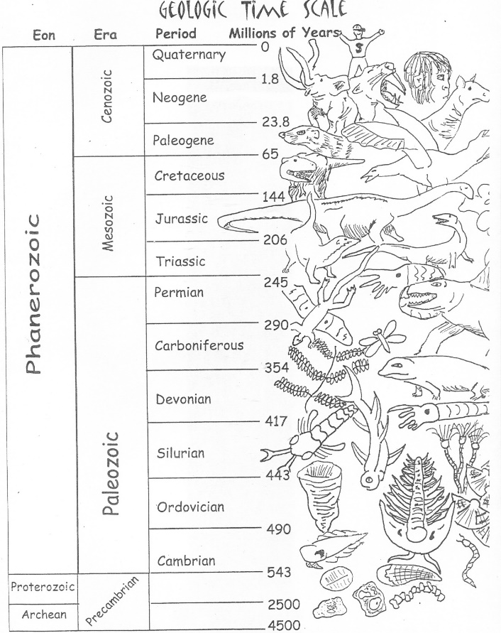
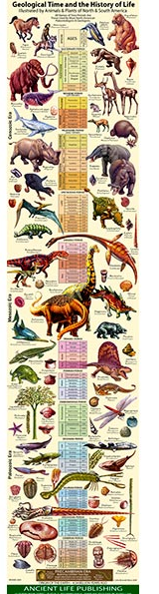
Chart (left) from https://www.petrifiedforestbookstore.com/shop/books/children/geological-timeline-and-the-history-of-life/
Coloring page (above) may be reproduced for non-commercial uses; please credit artist Lisa Whitenack

Activity: How is a dinosaur bone similar and different from a ‘modern’ bone?

Background
Is a fossil bone a bone or a rock? It’s a bone that has been altered usually by filling in the pore space with minerals from water percolating through the sediments in which it was buried. Because empty pore space is lighter than filled-in pore space a fossilized bone is heavier than a bone from a modern animal. Generally, the older the fossil, the longer the opportunity to become permineralized. Therefore, dinosaur bones millions of years old are generally well-mineralized and can survive weathering and erosion better than geologically younger bones, like those of Pleistocene (ice age) animals only thousands of years old.

Generally, fossil bones are heavier and darker in color than bones from modern animals.

Instructions
Invite visitors to compare the two bones and describe how they are different (color, weight)
Invite visitors to explain why the fossil bone is heavier and darker (dinosaur bone is much older so more time to become permineralized).

Find the “age of dinosaurs” on the geologic timescale chart and “today”. Talk about how much time separates the ‘age of dinosaurs’ and ‘today’ and how it’s so cool to find fossils of animals that old!

Materials
Fossil bone (see appendix for possible sources) or use a synthetic ‘bone’ from the next activity, below
Modern bone (see appendix)
Geologic time scale chart (see template in appendix)

Sliced and polished dinosaur bone showing mineral-filled vesicles.
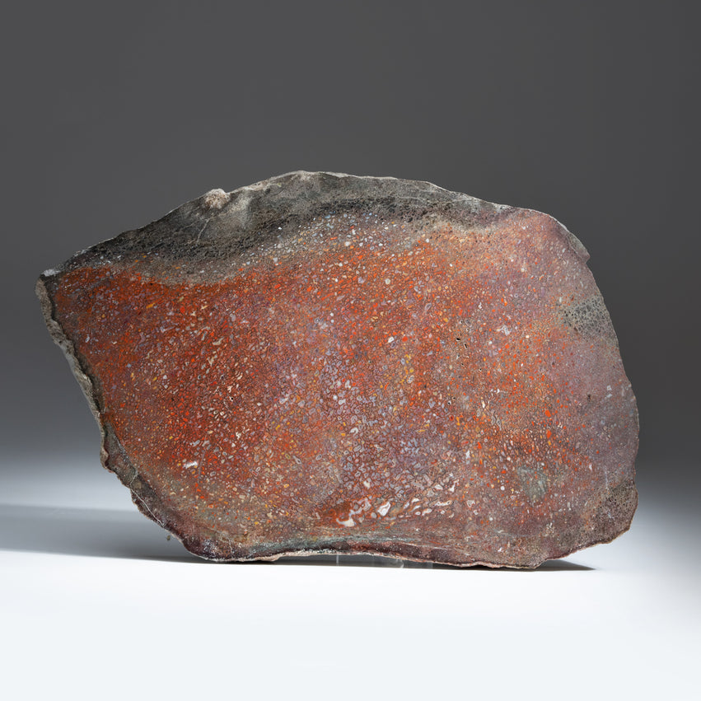

Demonstration: How are dinosaur bones fossilized?

Background
Most dinosaur bones are preserved by a process called permineralization. Bones, including dinosaur bones, are full of holes through which blood vessels flow while the animal is alive. After death, the soft tissues decay, leaving the holes-filled bone behind. After the animal is buried, water percolates through the sediment and the bone. Minerals in the water precipitate in the hollow spaces in the bone.

Preparation (a week in advance)
Make a supersaturated solution of water and Epsom salts. Pour the solution in the tray and submerge the sponge. Squeeze the air out of the sponge and thoroughly saturate the sponge with the Epsom solution. Allow the water to evaporate.

Materials
Synthetic sponges cut in the shape of a bone
Shallow plastic tray
Epsom salts (magnesium sulfate)
Water

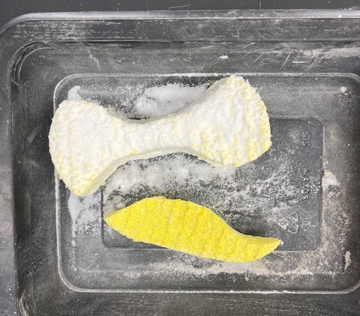

Part II: Birds and Dinosaurs

Background
Archaeopteryx a clear candidate for a transitional fossil between birds and dinosaurs. The chicken-sized fossil has both avian features (wings with feathers and a wishbone) and non-avian features (teeth, claws on the wings and a long, bony tail). Thus, Archaeopteryx plays an important role, not only in the study of the origin of birds, but in the study of dinosaurs.

Activity: Why do we think dinosaurs and birds are closely related?

Description
Many plants and animals become fossils because they lived in an ocean and were buried rapidly during big storms. The ocean is an environment in which many animals live. It is also an environment subject to large storms, like hurricanes, that can stir up sediment and rapidly re-deposit it. With the “Ocean in a jar” we can see what happens to animals living on the sea floor after a large storm.

Interaction
Invite participants to study the Archaeopteryx drawing (template, below) and to find and label the features mentioned on the handout as “bird” (B) or “dinosaur” (D).
Invite participants to compare the photos of the cassowary foot and therapod dinosaur footprint.

Materials
Archaeopteryx drawing or model
Picture of therapod dinosaur footprint (3-toed predator)
Picture of modern cassowary foot (3-toed predator)
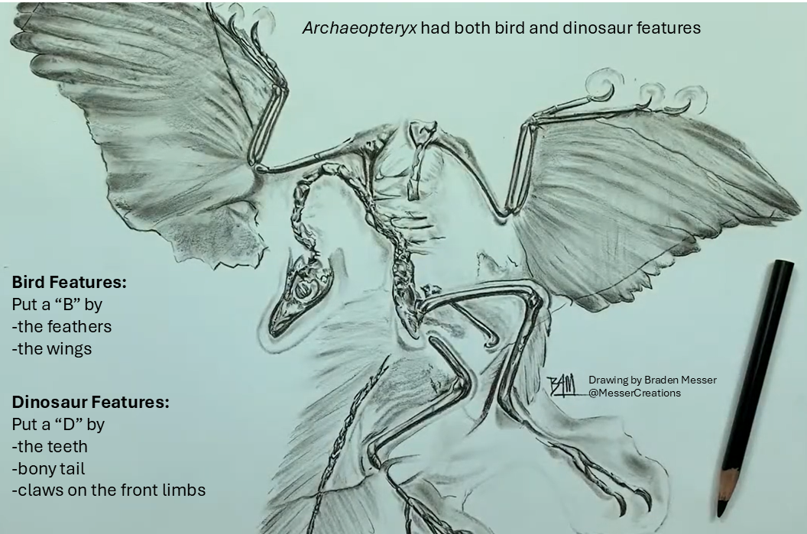

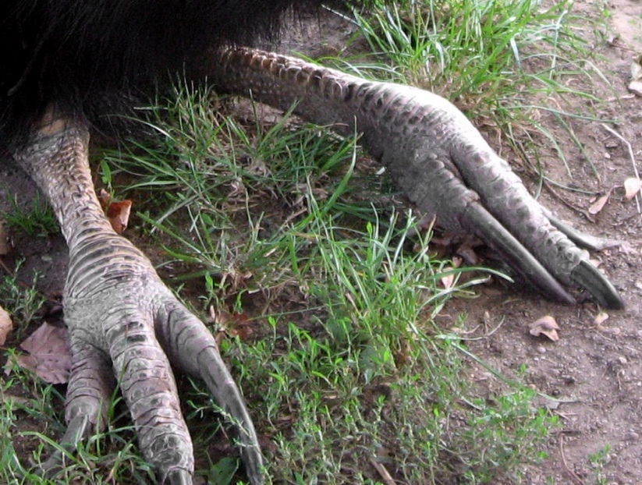

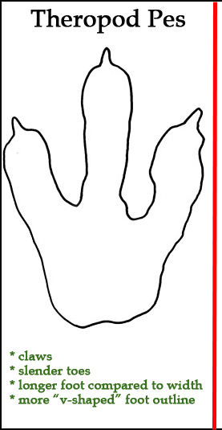
Cassowary feet. By Dezidor - Wikimedia Commons,
CC BY 3.0, https://commons.wikimedia.org/w/i
ndex.php?curid=102155421

Part III: Dinosaur Paleoart

Background
Fossil provide the only information we have about what dinosaurs looked like and how they lived. If we do not have the whole animal, we tend to fill in the gaps in our knowledge by making assumptions based on comparison of dinosaurs to animals we think are closely related.

Early dinosaur reconstructions were based on comparisons of dinosaurs to reptiles, like alligators and iguanas. Color illustrations from the time used shades of gray and green for dinosaurs and showed dinosaurs walking in a sprawled, close-to-the-ground gai.

Reconstructions change as more fossils are discovered and as our ideas about dinosaur relationships evolve. Today we hypothesize that the line of dinosaurs that includes T. rex are ancestors to birds. Reconstructions now show raptors as more active and in vivid colors (perhaps some were covered in feathers!).

Activity: Why have our ideas of what some dinosaurs looked like changed?

Instructions
Invite participants to describe the differences between the drawings of old and newer dinosaur reconstructions.

Materials
Photo/drawing pairs (old and new reconstructions) of dinosaurs to include:
Iguanodon (position of the “spike”; see illustrations, below)
T. rex (dragging tail vs. holding tail upright)
Sauropod (dragging tail vs. holding tail upright)
Stegosaurus (different interpretations of how the plates along the spine are arranged

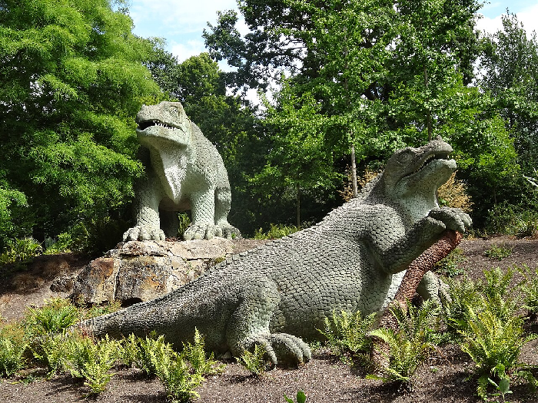
Dinosaurs at the Crystal Palace. Image source: https://commons.wikimedia.org/wiki/File:Mantellodon_in_Crystal_Palace_Park.jpg

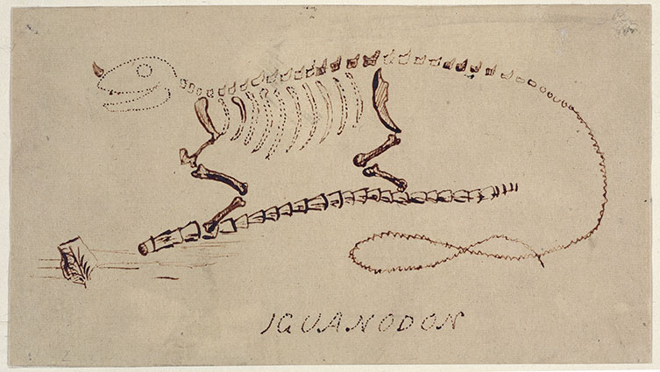

Gideon Mantell’s original reconstruction Iguanodon with the “spike” shown as a horn on the ‘nose’. Image from https://www.nhm.ac.uk/discover/the-discovery-of-iguanodon.html

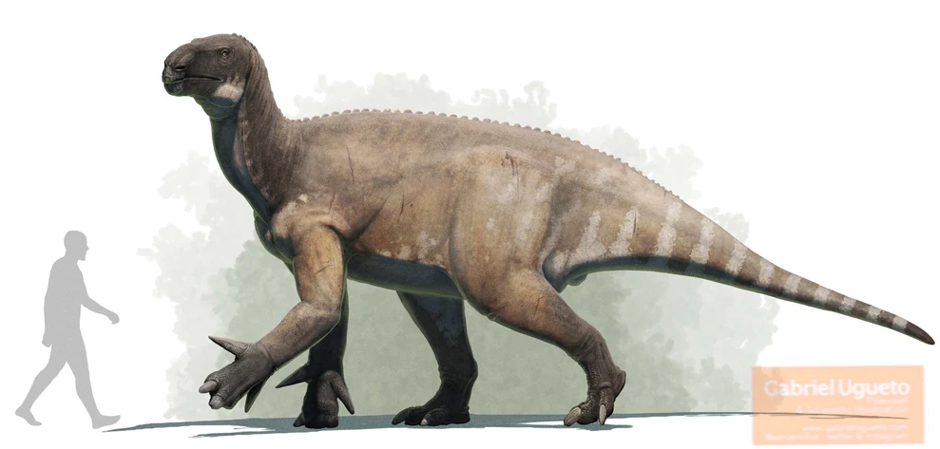

Modern reconstruction of Iguanodon with the thumb spike. Image from https://dinopedia.fandom.com/wiki/Iguanodon?file=Iggy.jpg

Part IV: Dinosaur Teeth and Claws

Background
Smooth stones found with dinosaur bones suggest that some dinosaurs swallowed stones to aid in digestion, as some modern birds do. These stones are usually made of quartz, which is a hard mineral that can survive the acidic environment of a dinosaur’s gut.

What goes in (food) eventually comes out (poop). Paleontologists call fossil poop “coprolites”. Biologists call poop of living mammals “scat.” Dinosaur coprolites (which are fossilized and not smelly or gross at all) come in a variety of shapes and sizes depending on the size of the dinosaur and its diet.

Activity: Dino Digestion-- In one end and out the other (gastroliths and coprolites)

Instructions
Invite participants to guess what the objects are (give hints as needed). Mention that chickens swallow stones to help digest food. Gastroliths are smoother than coprolites.

Compare the coprolite to drawings of modern ‘scat’ and invite the visitors to think about what we can learn about animals from their ‘poop’ (diet, whether they are herbivores or carnivores…) Because we do not have the rock saws needed to slice up dinosaur coprolites, a possible ancillary activity is to dissect owl pellets (kits available online)

Materials
Dinosaur gastroliths and coprolites (see appendix for sources)
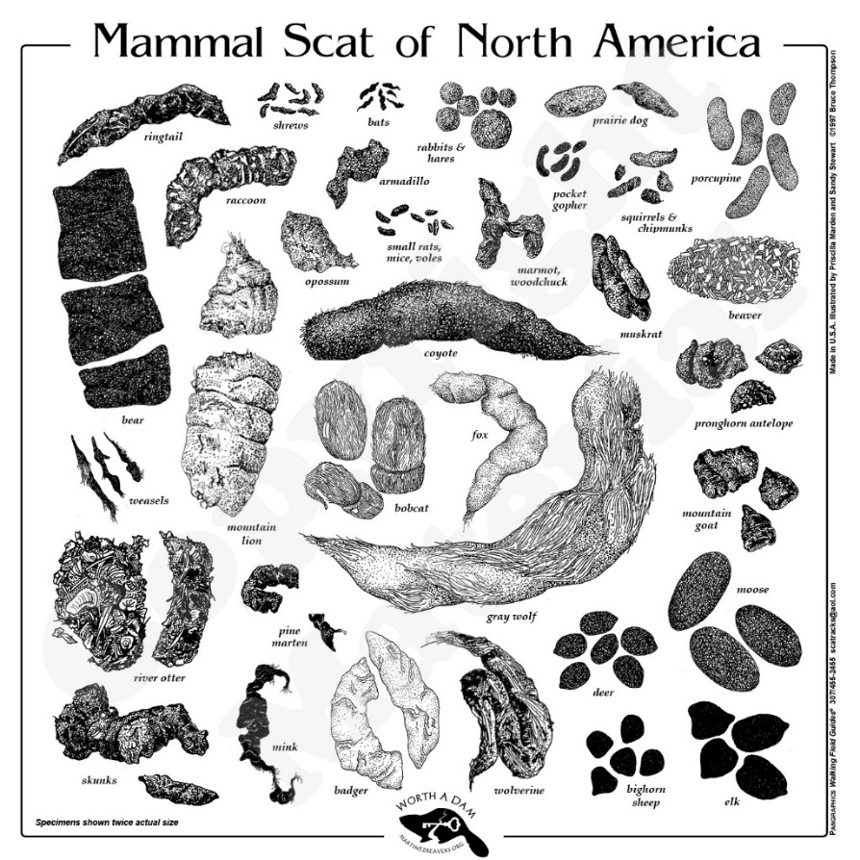
Audubon guide to animal tracks and scat

Activity: What did the dinosaur use this for? (dino teeth and claws)

Background
Fossils provide the only information we have about how what dinosaurs looked like and how they lived. If we do not have the whole fossil animal we make assumptions based on what animals we think are closely related and what they looked like

Activity: Dino Digestion-- In one end and out the other (gastroliths and coprolites)

Instructions
Invite participants to study and contrast the objects.
Prompt questions: Are these objects teeth? Claws?
How are the teeth and claws different and how are they similar in appearance?
Do you think they were used the same way?
Do you think these dinosaurs were meat eaters or plant eaters?
What would these teeth/claws have been used for?
Do you think these dinosaurs were meat-eaters or plant eaters? Why?

Materials
3-D print of dinosaur teeth and claws (see appendix) including
T. rex tooth
T. rex claw
Iguanodon thumb spike
Iguanodon (or other herbivious dinosaur) tooth plate
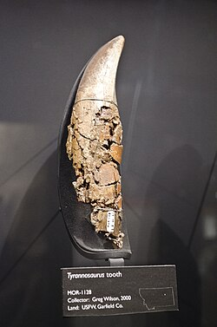
Left: Illustration of the original Iguanodon teeth by Gideon Mantell, 1825.
From Wikipedia entry on Iguanodon. Right: Tyrannosaurus tooth. From https://en.wikipedia.org/wiki/Dinosaur_tooth

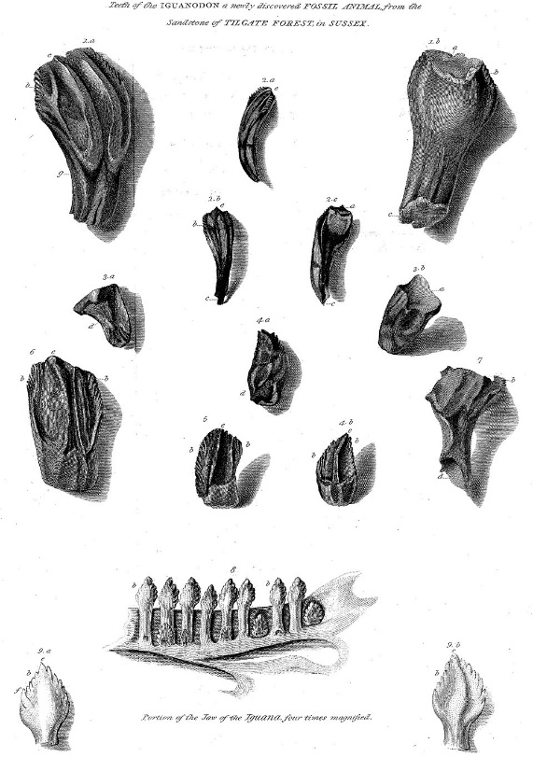

Part V: Why are there no Dinosaurs in Michigan?

Activity: Dinosaurs in Michigan are found only in museums

Background
There are no dinosaurs (or any other Mesozoic animals) known from Michigan because there is very little preserved rock from the Mesozoic. The little bit of Jurassic rock in Michigan contains pollen fossils that indicate the environment in Michigan during the Mesozoic was arid. During most of the Mesozoic Era there were no lakes or rivers or swamps, and certainly no ocean, as there was during the Paleozoic Era when the Petoskey stone coral lived in Michigan. Consequently, there were no depositional environments in which sediments could accumulate to form fossiliferous sedimentary rocks.

The modern day Badlands of South Dakota may be a good model of what Michigan looked like during the “Missing Mesozoic”. (see photo).

A common misconception is that Michigan has no dinosaurs because the Ice Age glaciers scraped away the Mesozoic rocks. Don’t blame the glaciers! The little bit of Jurassic rock we have in Michigan indicates that the glaciers aren’t to blame. If glaciers scraped away the Mesozoic rocks, they would have had to scrape away the older Triassic and younger Cretaceous sediments but leave behind the Jurassic layers in between (see chart of the Mesozoic, to the right). That is not physically possible!

Places that have a lot of dinosaur fossils (Wyoming, Colorado, Montana) were wetter than Michigan in the Mesozoic with many depositional environments--ocean shoreline, rivers and lakes—in which dinos could be buried and preserved (see paleogeographic map).
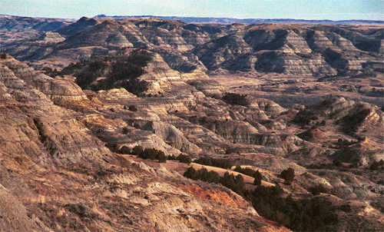

During the Mesozoic Era, Michigan had an arid environment much
like modern day Badlands of South Dakota, shown here

Instructions
We will interpret two different maps, a paleogeography map and a geologic bedrock map.

- Find Michigan on the paleogeographic map (below) and compare to the western US where dinosaurs are found.
From http://neotectonics.seismo.unr.edu/0_COURSES/Geo730-2024/aapowerpoints-2020/80-Neal%20-%20North%20America%20Paleogeographic%20Maps.pdf

- Find Michigan on the geologic map and note the age of the bedrock that underlies Michigan (Paleozoic Era). Locate and list states that have Mesozoic bedrock and are likely to have dinosaurs.

Materials
Paleogeographic map of North America
Geologic time chart
Geologic bedrock map of the U.S.
https://www.loc.gov/resource/g3701gm.gct00297/?sp=37&r=-0.019,0.023,1.108,0.655,0

Paper and pencil for making a list of states in the US where Mesozoic bedrock is preserved and potentially dinosaur hunting-ground.
List of Museums featuring dinosaur displays

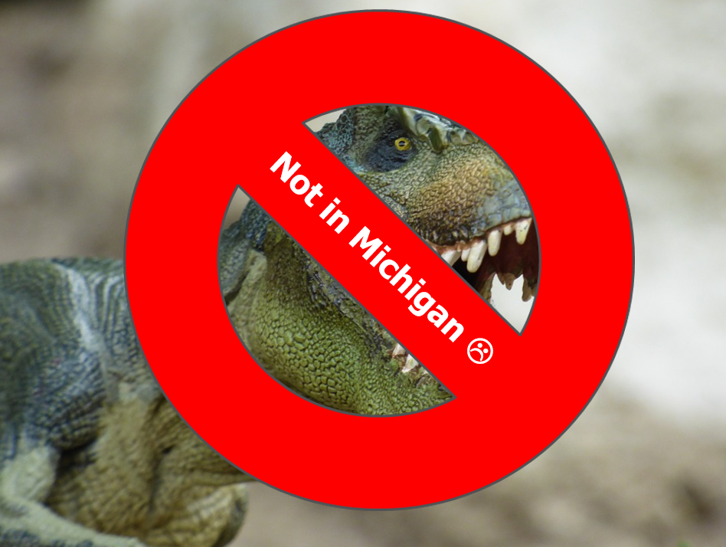
Where to see dinosaur displays in and near Michigan

Michigan State University Museum
University of Michigan Museum
Western Michigan University Dinosaur Park
Cranbrook Institute
Field Museum, Chicago
Cleveland Museum of Natural History

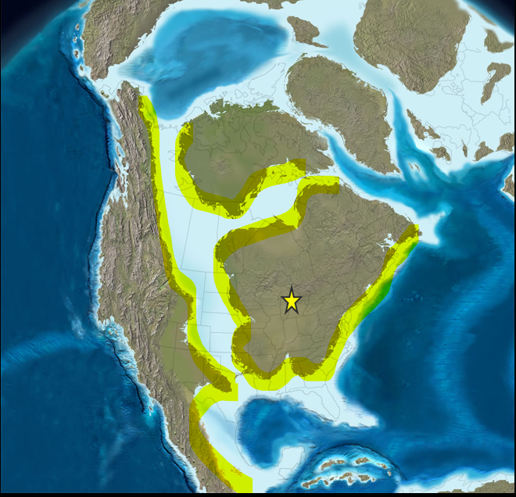

Paleogeographic map of North America during the Cretaceous Period of the Mesozoic Era. Michigan, and most of eastern North America, is “high and dry” with no large lakes, rivers, or ocean in which sediment could accumulate (and trap and bury plants and animals for future fossils).

The large seaway in western North America that extended from the Arctic to the Gulf provided much shoreline and rivers feeding into the it as good depositional environments in which sediments could accumulate and bury and preserve plants and animals.

The yellow highlight indicates areas where dinosaur fossils could be found. The yellow star marks our location in Michigan, far from dinosaur-bearing Mesozoic rocks.

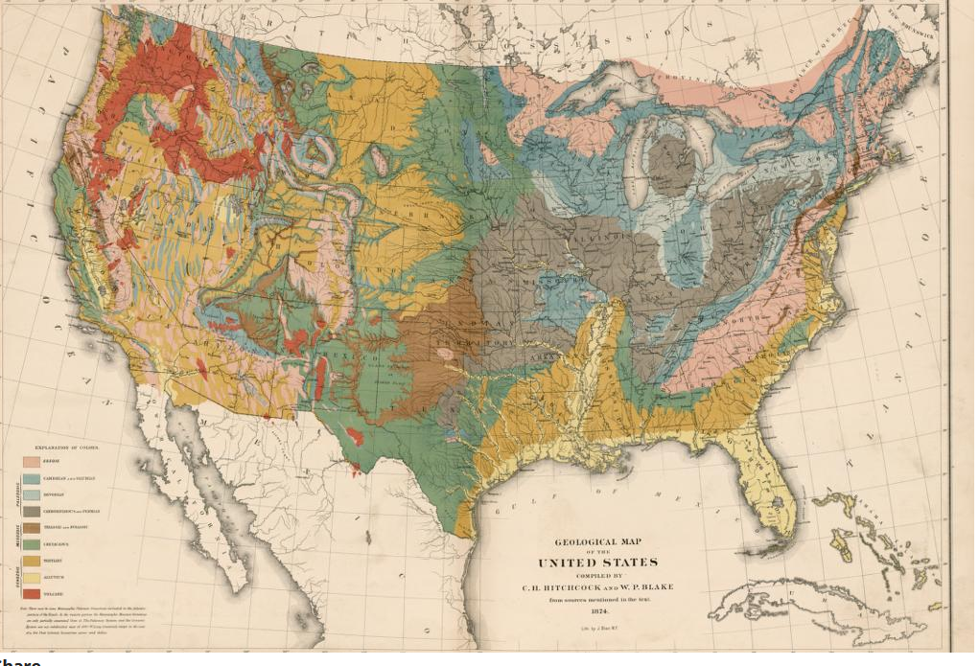
Geologic bedrock map of the United States. Mesozoic bedrock is indicated in the key as shades of light green (see Texas!). The blue and gray bedrock in Michigan is Paleozoic in age.

Part V: The End. How did dinosaurs go extinct?

Activity: How can we know what caused extinction millions of years ago?

Background
How can we know what caused extinction millions of years ago? The current favorite explanation for dinosaur extinction is that a large impact caused catastrophic environmental changes that led to dinosaur extinction at the end of the Cretaceous Period and brought the Mesozoic Era to its conclusion. This explanation is popular because the evidence for a large impact is incontrovertible and such a large impact surely would have affected life on Earth. But did a large impact and resulting environmental stress cause the extinction of the dinosaurs? That question is still debated by some paleontologists. The impact scenario is popular because it seems intuitive. But relying on intuition is not science. Documenting cause and effect in support of the impact extinction hypothesis has proven harder than documenting the physical evidence for the impact, because extinction is complicated.

The last major extinction was about 10,000 years ago, the extinction of the “Ice-Age Megafauna” (mammoths, mastodons, giant ground sloths, etc.). Scientists cannot agree on the cause of these extinctions that happened geologically yesterday (‘only’ 10 thousand years ago). How can we be confident that we understand extinctions that happened 60 million years ago?

Extinction is complicated.

Agreement among some scientists does not necessarily mean a popular explanation is correct. Other factors may have contributed to the decline and extinction of dinosaurs and other organisms at the end of the Mesozoic Era. Perhaps the impact was the last ‘nail in the coffin.’ New hypotheses come from constant questioning (testing) old hypotheses and there are many unanswered questions in attempting to explain what caused dinosaur extinction, because, extinction is complicated.

Instructions
Encourage participants to search online and from the shelves of your libraries for alternative hypotheses for dinosaur extinction.

Complete the chart for the major extinctions and their proposed causes.
Wikipedia has a list of “Extinction events” here: https://en.wikipedia.org/wiki/List_of_extinction_events

What conclusions can you draw from making these comparisons?
[Hint: Extinction is complicated.]

Materials
Websites
Books from your shelves on dinosaurs, extinction
Extinction spreadsheet (below)
An open and inquiring mind

Extinctions through the history of the Earth & proposed causes (there are many options, expand table as necessary)

Geologic interval | Proposed cause(s)

Materials List
Item | Supplier/Information
General supplies
Pencils
Various size of paper
scissors
What is a Dinosaur?
Dinosaur models | Various online and commercial vendors, 3D print
Mammal, bird, reptile models | Various online and commercial vendors, 3D print
How Big Were Dinosaurs?
Therapod footprint template | https://www.istockphoto.com/vector/dinosaur-paw-monster-lizard-footprint-dino-black-silhouette-footstep-t-rex-fossil-gm1934507383-556179057
Sauropod footprint template
Archaeopteryx footprint template
cardboard
scissors
When (How long ago) did dinosaurs live? (million dots)
Geologic timeline chart | Ordering information is included in the activity description
Timeline coloring sheet | Template is included in the activity description
Paper and markers
calculator
How Much is a Million | David M. Schwartz and Steven Kellogg
Why we think dinosaurs and birds are related
Archaeopteryx drawing or model
Therapod dinosaur footprint | Cut-out or picture
Cassowary footprint | Cut-out or picture
How is a dinosaur bone similar and different from a modern bone?
Fossil bone | Online vendors or use the synthetic bone (below)
Modern bone
Geologic time scale chart
How are dinosaur bones fossilized?
Synthetic sponges
Shallow plastic trays
Epsom salts (magnesium sulfate)
Water
Dino digestion--In one end and out the other
Gastroliths | Various online vendors (can be simulated with smooth quartz pebbles)
Coprolites | Various online vendors
A field guide to animal tracks | Peterson field guide series volume by O.J. Muria includes drawings of animal scat
Why have our ideas of what some dinosaurs looked like changed?
Iguanodon reconstructions | Old version: spike on nose; new version
T. rex reconstructions | Old version: dragging tail; new version, see Sue
Sauropod reconstructions | Old version: dragging tail; new version not
What did the dinosaur use this for? (teeth and claws)
T. rex tooth replica | Various online vendors, 3D print
T. rex claw replica | Various online vendors, 3D print
Iguanodon thumb spike replica | Various online vendors; 3-D print
Herbivorous dino tooth replica | Online vendors, 3-D print
Dinosaurs in Michigan are found only in museums
Paleogeographic map of North America | Included in activity description
Geologic time chart | See above
Geologic bedrock map of the U.S. | Website address is included in the activity description
The End. How did dinosaurs go extinct?
Internet access
Extinction spreadsheet | Template is included in the activity description
Books from your shelves

General Paleontology Resources

Websites
Friends of the University of Michigan Museum of Paleontology Specimen Database:
http://strata.geology.wisc.edu/mibasin/
Website with lots of photographs of fossils, many of which can be found in the Great Lakes region

iDigBio. A database for paleontology enthusiasts. https://www.idigbio.org/education

Paleontological Research Institute’s Digital Atlas of Ancient life. https://www.digitalatlasofancientlife.org/

The Paleontological Society. The largest professional society for paleontologists includes resources for students and educators and a page where you can ask for help in identifying your fossil. https://www.paleosoc.org

The Paleobiology Database. A professional data repository, there are some accessible functions for the non-professional. https://paleobiodb.org/#/resources

Royal Ontario Museum Image Database: http://images.rom.on.ca/public/

University of California Museum of Paleontology Online Exhibits:
http://www.ucmp.berkeley.edu/exhibits/index.php
Extensive website with many images and background information for every major fossil group; also has extensive K-12 educational resources, online activities, modules, etc.

Books (classics)
Aliki. 1990. Fossils Tell of Long Ago. HarperCollins Publishers, New York.

Eldredge, Niles, Gregory Eldredge, and Douglas Eldredge. 1989. The Fossil Factory: A Kid’s Guide to Digging Up Dinosaurs, Exploring Evolution, and Finding Fossils. Roberts Rinehart, Lanham, MD.

Katz Cooper, Sharon. 2007. Learning from Fossils. Heinemann Library, Chicago.

Squire, Ann O. 2002. Fossils: A True Book. Children’s Press (Scholastic Inc.), New York.

Strain Trueit, Trudi. 2003. Fossils. Franklin Watts (Scholastic Inc.), New York.

Taylor, Paul D. 2004. Eyewitness Fossil. DK Publishing, Inc., New York.

